OPINION

How the U.S. Made the Ebola Crisis Worse

The total number of Liberian doctors in America is about two-thirds the total now working in their homeland.
By
E. FULLER TORREY
Oct. 14, 2014 7:19 p.m. ET
Amid discussions of quarantines, lockdowns and doomsday death scenarios about Ebola, little has been said about the exodus of Africa’s health-care professionals and how it has contributed to the outbreak. For 50 years, the U.S. and other Western nations have admitted health professionals—especially doctors and nurses—from poor countries, including Liberia, Sierra Leone and Guinea, three nations at the heart of the Ebola epidemic.
The loss of these men and women is now reflected in reports about severe medical-manpower shortages in these countries, an absence of local medical leadership so critical for responding to the crisis, and a collapse or near-collapse of their health-care systems.
Although Africa bears 24% of the global disease burden, it is home to just 3% of the world’s health workforce. A 2010 World Health Organization assessment of doctors, nurses and midwives per population listed Liberia, Sierra Leone and Guinea in the bottom nine nations in the world in medical manpower.
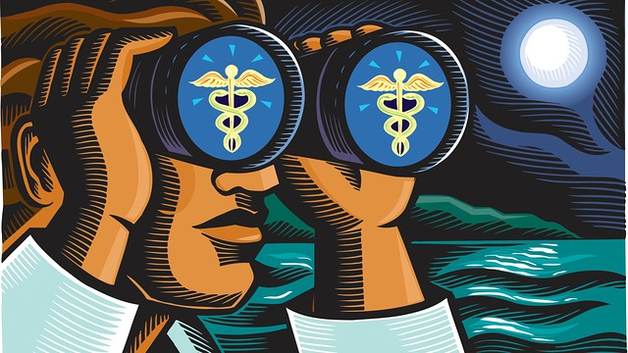ENLARGE
CORBIS
In Liberia, a nation of four million people, the number of Ebola cases is said to be doubling every 15-20 days. Based on news reports, I’ve estimated that there were about 120 Liberian physicians in the country prior to the outbreak.
According to an American Medical Association database, in 2010 there were 56 Liberian-trained physicians practicing in the U.S. This number does not include other Liberian physicians who emigrated to this country, were unable to pass state licensing exams, and are employed as technicians, administrators, or in other jobs. Older studies suggest that the number failing such exams is about half of those licensed.
Thus the total number of Liberian physicians in the U.S. is probably about two-thirds the number in Liberia. In addition, Liberian-trained physicians live in Canada, Great Britain and Australia.
The Liberian situation is not exceptional. Altogether in 2010 the U.S. had 265,851 licensed physicians trained in other countries, constituting 32% of our physician workforce, according to the AMA. Among these, 128,729 came from countries categorized by the World Bank as being from low- or lower-middle income countries. These physicians tend to work disproportionately in rural and inner-city jobs less favored by American medical graduates. West Virginia, for example, has the highest proportion of foreign-trained physicians from poorer countries to U.S.-trained physicians.
The U.S. has always welcomed health professionals from other countries. However in 1965, responding to a perceived shortage of physicians for the growing U.S. population, Congress passed landmark immigration legislation giving preference to health professionals. Subsequent legislation in 1968, 1970 and 1994 further opened the door, especially for physicians from poorer countries. The percentage of foreign-trained physicians has steadily increased from 10% of the workforce in 1965 to its current 32%.
Many objections to this policy have been raised over the years. In 1967 Walter Mondale, then a senator from Minnesota, called it a disgrace. It was “inexcusable,” he wrote in the Saturday Review, that the U.S. should “need doctors from countries where thousands die daily of disease to relieve our shortage of medical manpower.”
A 1974 report on the “Brain Drain” for the House Foreign Affairs Committee noted that the current policy was widening the gap between rich and poor nations, and warned that the policy “has a great potential for mischief in the Nation’s future relations with the LDC [less developed countries].”
Despite such complaints, U.S. policy has continued to encourage the immigration of physicians and other health workers from poorer countries. “There’s nothing wrong with a foreign-trained doctor,” Casper Weinberger, then secretary of the Department of Health, Education and Welfare, said on TV in 1973. “Of course we’re using a lot of them, and will use a lot more.”
The consequences of this policy may be more than “mischief.” Ebola may be merely the first of many prices to be paid for our long-standing but shortsighted health manpower policy. Surely the wealthiest country in the world should be able to produce sufficient health workers for its own needs and not take them from the poorest countries.
Dr. Torrey is associate director of the Stanley Medical Research Institute and author of “American Psychosis: How the Federal Government Destroyed the Mental Illness Treatment System” (Oxford, 2013).

