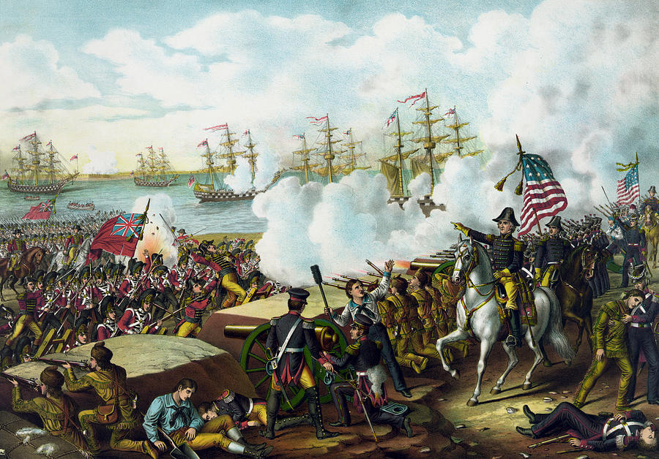

Chapter 8 Lesson Overview
Democratic Order
Description: Under Thomas Jefferson’s presidency, the two party system flourished as it transitioned into the ‘Era of Good Feelings’. Continued conflict with the British, however, resulted in the War of 1812 which defined our relationship with foreign states for the future. James Monroe’s presidency saw continued growth for the nation with the Monroe Doctrine.
Topics:
- Key Terms:
- Louisiana Purchase
- Marbury v. Madison
- John Marshall
- Lewis and Clark expedition
- Burr conspiracy
- Embargo Act
- Non-Intercourse Act
- Tecumseh
- War of 1812
- Battle of New Orleans

- Concepts:
- Democratic Party and Federalist Party
- Growth of economies
- War of 1812

- Assignments:
- Assignment
- Description: Lewis and Clark Assignment (20 points)
- Students explore Lewis and Clark’s expedition across America.
- Assessments:
- Quiz 1
- Quiz 2

Overview Questions (10 Points)
- Thomas Jefferson has a very mixed legacy: some celebrate him as a brilliant intellectual and freedom fighter, others view him as a hypocrite and elitist; still others point to his purportedly lackluster presidency. Assess the efficacy of Jefferson's presidential administration (1801-1809) – the pros and the cons – and the overall legacy of this much-disputed historical figure.

- Was Jefferson wise to purchase the Louisiana Territory from France? Consider such issues as its dubious constitutionality and encroachment on Indian land, but also its vast expansion of American boundaries and new economic opportunities for freeholding farmers.

- Was the War of 1812 a just war? Was there legitimate cause to declare war on Great Britain, as the Democratic-Republicans so clamored for? Or was it a foolhardy, rash action by impatient war hawks, as the Federalist Party argued?

Assignment 1
Lewis and Clark Assignment
(20 points)

Instructions: Answer the following questions using the following links and or use your textbook or on-line textbook:
- https://lewisclark.net/
- https://www.history.com/topics/lewis-and-clark
- http://www.pbs.org/lewisandclark/

Short Answer:
- Who was the President that sent Lewis and Clark on the expedition? (1 point)

- Why did Lewis and Clark explore the Western part of the United States? (1 point)

- What did the Native Americans do to help Lewis and Clark on their expedition? (1 point)

- List 5 animals, 5 plants, and 5 Indian tribes discovered by the expedition. (15 points)

Animals |  | Plants |  | Indian Tribes
a.
b.
c.
d.
e.

- Describe the Journey of Lewis and Clark. Where did they begin and end their journey? What geographic obstacles did they face along the way? (1 point)

- What stood out as interesting to you about their journey? If you had the opportunity, would you have joined them? Why or why not? (1 point)

