Trail of Tears Project Materials
1830 Map Showing Cherokee Nation within Georgia

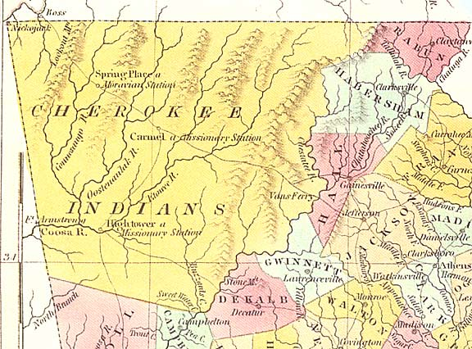

Map of Cherokee Removal Routes
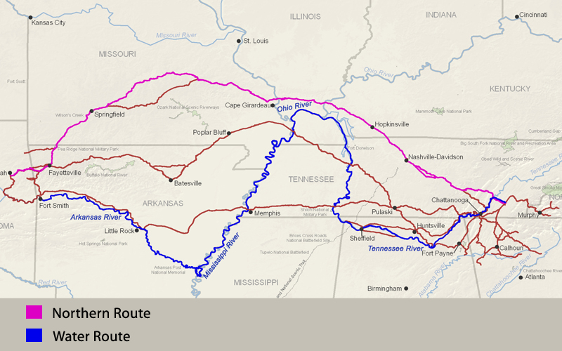
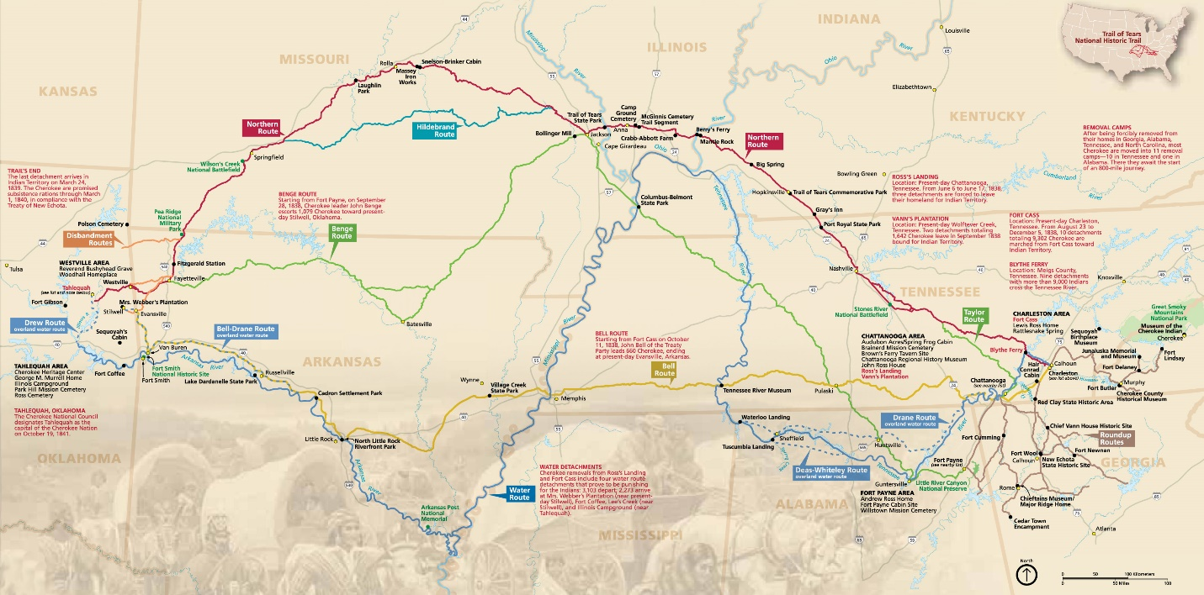

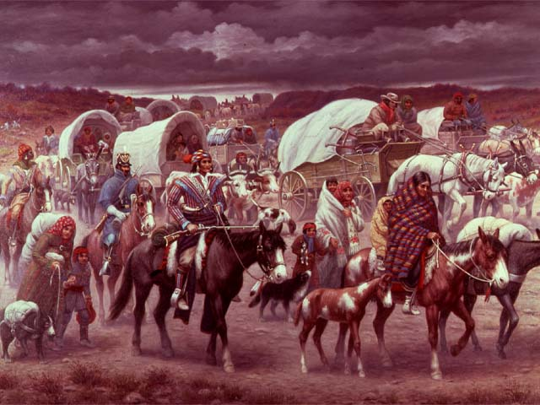
In 1838 and 1839, as part of Andrew Jackson's Indian removal policy, the Cherokee nation was forced to give up its lands east of the Mississippi River and to migrate to an area in present-day Oklahoma. The Cherokee people called this journey the "Trail of Tears," because of its devastating effects. The migrants faced hunger, disease, and exhaustion on the forced march. Over 4,000 out of 15,000 of the Cherokees died.
This picture, The Trail of Tears, was painted by Robert Lindneux in 1942. It commemorates the suffering of the Cherokee people under forced removal. If any depictions of the "Trail of Tears" were created at the time of the march, they have not survived.

Cherokee Nation Timeline
1450 - Cherokee migrate from northwestern to what is now southeastern United States.
1540 - DeSoto becomes first white settler to see Cherokee tribe.
1650 - Cherokee Nation encompasses more than 40,000 square miles in Southern Appalachia. Population estimated at 22,500.
1710 - Cherokees begin trade with white settlers
1773 - Cherokees sign Treaty of Augusta ceding 2,000,000 acres of Cherokee land in Georgia to relieve indebtedness to white settlers.
1776 -1783 - Fearing encroachment, Cherokee side with British during American Revolution.
1791 - Treaty of Holston: President Washington agrees that Americans must obtain passports to enter Cherokee lands. Cherokee granted right to evict settlers. In exchange, Cherokee cede land in eastern Tennessee.
1802 - Thomas Jefferson, in State of Nation Address, commits United States to the work of settling and "marking boundaries" for Indians, thereby initiating removal policy.
1805-1832--Land Lotteries divide Cherokee territory among whites.
1821 - Sequoyah develops Cherokee alphabet.
1828 - Cherokee Nation adopts written Constitution. Publication of first Indian newspaper, Cherokee Phoenix.
Andrew Jackson elected President. Carries Southern states with pro- Indian removal platform
1830 - Gold discovered on Cherokee land in western Georgia.
Congress passes Indian Removal Act. Jackson claims Removal Act will replace "savage hunters" with "civilized population." Greater than 90% of Cherokee Nation can read and write, and they are an agrarian society.
1831 - Cherokee Nation vs. Supreme Court filed to protest Cherokee Removal Act. Supreme Court refuses to hear case on basis that Cherokee are not a "sovereign nation."
1832 - In Worcester v. Georgia, Supreme Court rules Cherokee Nation is sovereign. Georgia has no jurisdiction over Cherokee nor claim to Cherokee lands. Removal Law invalid and illegal. Jackson realizes he must have agreement of Cherokee to proceed with removal. Authorized payments of $2,000 per individual to influence Cherokee to sign removal treaty.
1835 - Treaty of New Echota signed; Cherokee agree to removal.
Major Ridge, his son John, and Elias Boudinot lead faction who sign treaty.
Chief John Ross, who opposes treaty, is under house arrest at time for unspecified charges.
Chief John Ross gathers 16.000 signatures of those who oppose removal treaty. United States Senate ratifies Treaty of New Echota.
1838 - General Wool of United States Army assigned to removal project. Resigns his command in protest.
General Winfield Scott, with 7,000 troops, removes Cherokee to Indian Territory.
1838 - 15,000 Cherokee gathered into forts, their homes plundered and burned. A few hundred Cherokee escape to mountains.
1839 - Major Ridge, John Ridge, Elias Boudinot assassinated.
1838-39 - 4,000 Cherokee die on "Trail of Tears" as they are forced to march 1,200 miles through Tennessee, Kentucky, Illinois, Missouri, and Arkansas.

http://www.pbs.org/wgbh/aia/part4/4h3083t.html
Cherokee letter protesting the Treaty of New Echota

Letter from Chief John Ross, "To the Senate and House of Representatives"
[Red Clay Council Ground, Cherokee Nation, September 28, 1836]
It is well known that for a number of years past we have been harassed by a series of vexations, which it is deemed unnecessary to recite in detail, but the evidence of which our delegation will be prepared to furnish. With a view to bringing our troubles to a close, a delegation was appointed on the 23rd of October, 1835, by the General Council of the nation, clothed with full powers to enter into arrangements with the Government of the United States, for the final adjustment of all our existing difficulties. The delegation failing to effect an arrangement with the United States commissioner, then in the nation, proceeded, agreeably to their instructions in that case, to Washington City, for the purpose of negotiating a treaty with the authorities of the United States.
After the departure of the Delegation, a contract was made by the Rev. John F. Schermerhorn, and certain individual Cherokees, purporting to be a "treaty, concluded at New Echota, in the State of Georgia, on the 29th day of December, 1835, by General William Carroll and John F. Schermerhorn, commissioners on the part of the United States, and the chiefs, headmen, and people of the Cherokee tribes of Indians." A spurious Delegation, in violation of a special injunction of the general council of the nation, proceeded to Washington City with this pretended treaty, and by false and fraudulent representations supplanted in the favor of the Government the legal and accredited Delegation of the Cherokee people, and obtained for this instrument, after making important alterations in its provisions, the recognition of the United States Government. And now it is presented to us as a treaty, ratified by the Senate, and approved by the President [Andrew Jackson], and our acquiescence in its requirements demanded, under the sanction of the displeasure of the United States, and the threat of summary compulsion, in case of refusal. It comes to us, not through our legitimate authorities, the known and usual medium of communication between the Government of the United States and our nation, but through the agency of a complication of powers, civil and military.
By the stipulations of this instrument, we are despoiled of our private possessions, the indefeasible property of individuals. We are stripped of every attribute of freedom and eligibility for legal self-defence. Our property may be plundered before our eyes; violence may be committed on our persons; even our lives may be taken away, and there is none to regard our complaints. We are denationalized; we are disfranchised. We are deprived of membership in the human family! We have neither land nor home, nor resting place that can be called our own. And this is effected by the provisions of a compact which assumes the venerated, the sacred appellation of treaty.
We are overwhelmed! Our hearts are sickened, our utterance is paralized, when we reflect on the condition in which we are placed, by the audacious practices of unprincipled men, who have managed their stratagems with so much dexterity as to impose on the Government of the United States, in the face of our earnest, solemn, and reiterated protestations.
The instrument in question is not the act of our Nation; we are not parties to its covenants; it has not received the sanction of our people. The makers of it sustain no office nor appointment in our Nation, under the designation of Chiefs, Head men, or any other title, by which they hold, or could acquire, authority to assume the reins of Government, and to make bargain and sale of our rights, our possessions, and our common country. And we are constrained solemnly to declare, that we cannot but contemplate the enforcement of the stipulations of this instrument on us, against our consent, as an act of injustice and oppression, which, we are well persuaded, can never knowingly be countenanced by the Government and people of the United States; nor can we believe it to be the design of these honorable and highminded individuals, who stand at the head of the Govt., to bind a whole Nation, by the acts of a few unauthorized individuals. And, therefore, we, the parties to be affected by the result, appeal with confidence to the justice, the magnanimity, the compassion, of your honorable bodies, against the enforcement, on us, of the provisions of a compact, in the formation of which we have had no agency.

Transcript of President Andrew Jackson's Message to Congress 'On Indian Removal' (1830)

https://www.ourdocuments.gov/doc.php?flash=false&doc=25&page=transcript

