Oregon Trail Project
Grade: 8th Grade
Topic: This project focuses on the Oregon Trail, a subtopic within the broader topic of Westward Expansion, which is required teaching in the 8th grade curriculum.
Content Areas: American History, Geography, and Language Arts
Objectives and Learning Targets:
- Students will make a map that traces the Oregon Trail
- Students will read expository text, paraphrase the information and report to the rest of the class.
- Students will explore Internet Web sites for information pertaining to the Oregon Trail
- Students will use and utilize internet and compare with the textbook its accuracy with facts they researched
- Students will create a flyer that outlines advice for helping travelers survive the trail
- Students will answer the questions asked of them to answer for this project
Overview and details on the Oregon Trail
- The Oregon Trail covers approximately 2000 miles of the western United States, stretching between Missouri and Oregon or California (depending on the western branch of the trail).
- The origins of the trail were made by beaver trappers and traders, who hunted along the great rivers of Oregon, and sought the best paths back through the mountains and plains to get their furs to the cities of the east.
- Husband and wife missionaries also traveled west through the Great Plains and Mountain West, and helped plot out paths that wagons could travel because they were bringing all home items necessary to permanently settle in Oregon. The early missionaries encouraged permanent American settlement of families in Oregon.
- The United States government also wanted Americans to settle in Oregon in order to keep British settlers out of the region. To accomplish this, they paid explorers to learn about the land, map it, and promote it for potential settlers.
- Oregon proved to be very attractive for potential settlers (particularly compared to the Great Plains, which had few rivers and trees). Oregon offered fertile land for agriculture, seaports and large rivers for commerce and fishing, and abundant forests for hunting and logging. In all this, Oregon had everything families could want to survive and thrive.
- The first organized wagon trains (wagons used to transport entire families and home contents) began in 1841 and 1842.
- In the spring of 1843, approximately 1,000 pioneers made the journey at one time—this journey is called the Great Migration.
- Because wagons could travel the entire trail, families looking for land and a way to make a living were able to relocate permanently to Oregon. Having entire family units arrive together enabled Oregon’s early growth.
- The mass influx of people settled in Oregon’s early population centers, especially in the fertile Willamette River Valley.
- The average journey by wagon took four to six months (at 15 miles a day).
- To encourage more settlement in Oregon, the early settlers in the Willamette River Valley granted new settlers hundreds of acres of land for free.
- Around 300,000 to 400,000 pioneers traveled the Oregon Trail between 1840 and 1860, many settling in Oregon.
- The journey started in Independence, Missouri, although people came from around the world.
- About one-third of the way through the trip, the settlers would pass the landmarks of Chimney Rock and Scotts Bluff.
- The next major milestone was Fort Laramie, which is now in the state of Wyoming.
- From Fort Laramie, travelers would cross the Rockies to Fort Bridger, to Fort Hall, and then to Fort Boise.
- The last leg started from Fort Boise, from where they would cross the Blue Mountains into Oregon
Student's Tasks:
The project is for you as the student to examine what it would have taken to take the opportunity to head west for free land and a new beginning. You and your partner have many details to explore and many questions to answer as it pertains to this assignment/project. Below, you will find questions to answer, information to explore, and links to websites that will help guide you to the information you need to make decisions for your journey to the Oregon Territory. Remember to take notes on important details you find to help you complete this project. Your notes will be very important for you to refer to as you create your presentation.
Follow these steps:
- First, you will need to choose up to three partners (has to be someone in this hour) (You may also work alone if you would like) for your journey.
- Next, you will need to learn about your journey so you can plan details, be prepared and make decisions. Remember to utilize your time wisely in the computer lab.
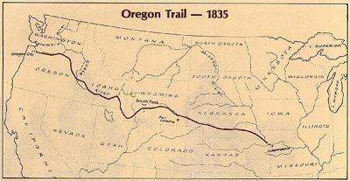

Chronology of the Oregon Trail:
https://historicoregoncity.org/2019/04/03/oregon-trail-chronology/
Find list of supplies for your journey:
https://oregontrailcenter.org/supplies
Getting Oxen, mules, or horses for your voyage:
https://oregontrailcenter.org/mules-oxen
Pack your wagon for your trip:
https://oregontrailcenter.org/the-wagon
Need to research on your own for what necessary tools, medicine, and food you need for the journey:

Project Task and questions to answer
Choosing where to go?
Need to pick where you want to settle in the Oregon Territory
How do we get there?
Explain how you got to the Oregon territory via the Oregon Trail.
Look at trail maps on-line in order to create your map:
Draw and create a map of the route you took for your journey along the Oregon Trail.
Learn how others were able to successfully navigate the Oregon Trail. Answer the following questions below
What do you need for your journey?
Write down your list of supplies as you will have a $100 dollar budget.
See PDF file of price for supplies

Choose the right kind of wagon for your journey
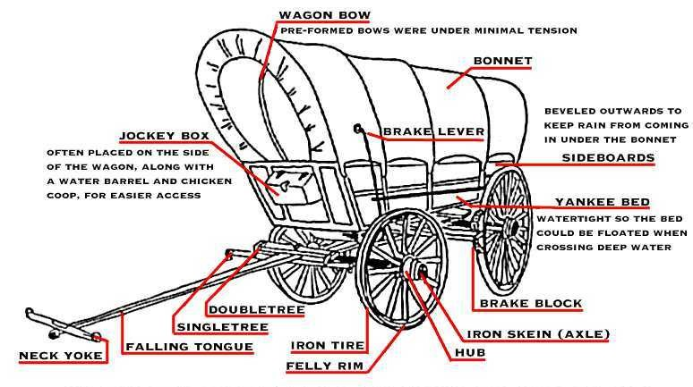
Research and pick the wagon that your group prefers for your journey
List all of the problems, obstacles, and difficulties that you may occur and face on your journey.

Explain to the class in detail where you settled and what was your group’s motivations and reasons on why you choose to go on the Oregon Trail.
*You and your group will present your journey on the Oregon Trail to the rest of the class.

