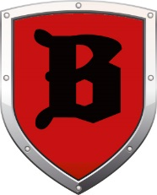
End of the Week
Weekly Updates and Reminders
Mr. Kay’s Reminders and Updates:

- The test make ups for the chapter 8 exam for those studnets who were absent before mid-winter break were yesterday right after school and today before school at 7:10 am.
- The Monroe Doctrine Project packet that was passed out in class early this week, is due on Wednesday, March 6th.
- The Chapter 9 Guided Reading packet is due this Friday.
- Chapter 9 Study Guide will be passed out on Friday.
- Please visit: https://mrkay.weebly.com/8th-grade-social-studies.html for further content, information, and learning materials.
- March 7th is the showing of the documentary of “Screenagers”. It is at 6:30. AN AWARD-WINNING FILM THAT PROBES INTO THE VULNERABLE CORNERS OF FAMILY LIFE AND DEPICTS MESSY STRUGGLES OVER SOCIAL MEDIA, VIDEO GAMES AND ACADEMICS. THE FILM OFFERS SOLUTIONS ON HOW WE CAN HELP OUR KIDS NAVIGATE THE DIGITAL World.” WORLD.

Upcoming event for Beer Middle School:

- March 7- Screenagers Movie

