Chapter 7 Study Guide

Know the below Key Terms, People, and Job Occupations

 | serf |  | fief
 | troubadour |  | charter
 | apprentice |  | St. Francis of Assisi
 | Clovis |  | papal supremacy
 | journeyman |  | knight

Pope Leo III proclaimed Charlemagne to be Emperor of the Romans because Charlemagne had……….

What was a result of the Treaty of Verdun in 843?

Part of a vassal’s obligation under his feudal contract was to do what?

Marriage in noble society often included fierce negotiations over what?

When the ownership of a manor was granted to a new lord, the serfs had to do what?

To achieve salvation, medieval Christians believed that they must do what?

Under Benedictine Rule, monks and nuns took vows of blank

The Truce of God required Christian nobles to do what?

What crop restored fertility to the soil in the three-field system of rotating crops?

Newcomers to a medieval city often settled in the fields outside the city walls because…

What was a purpose of the missi dominici that Charlemagne sent throughout his kingdom?

What important step did King Clovis take in ruling his conquered lands in the late 400s?

Starting in the late 700s, which group attacked Western Europe from the sea and broke the last threads of
unity in Charlemagne’s empire?

Feudalism developed as a way for medieval societies to do what?

A vassal owed his first loyalty to his blank

In the manor system, the peasants had to what?

In the later Middle Ages, the Church had what power over Europe?

What was the result of the Church reforms of Pope Gregory VII in 1073?

The claim of papal supremacy held that the church could do what?

Friars differed from other monks in that they could do what?

Poor women who were not accepted as nuns in other religious orders were welcome to join the blank

What commercial practice did Europeans adopt from the Muslim merchants with whom they traded?

The new middle class in medieval society included who?

As a response to overcrowding, residents of medieval cities built what?

Describe Below Diagram
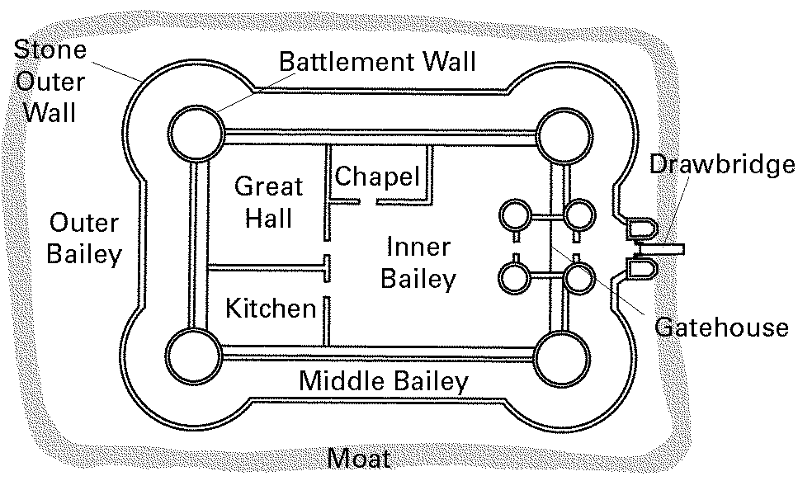
Describe Chivalry

