Name: _____________________________________ Hour: _______ Date: ________________________
Chapter 5 STUDY GUIDE

- From the Platform of the American Anti-Imperialist League, October 18, 1899:

“The United States has always protested against the doctrine of international law which permits the subjugation of the weak by the strong (This means: The U.S. has always been against any laws between countries that lets a stronger country take advantage of a weaker country) . . . The United States cannot act upon the ancient heresy (bad decisions made long ago) that might (power) makes right.”

WHAT DOES THE AUTHOR MEAN WITH THE LAST SENTENCE?
- What does this chart compare and contrast with Presidents Roosevelt and Wilson?
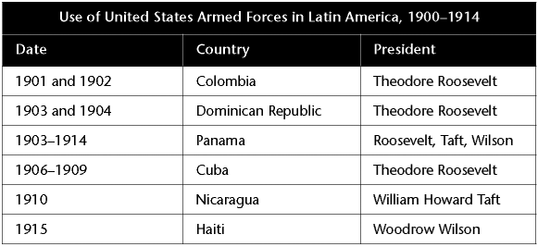

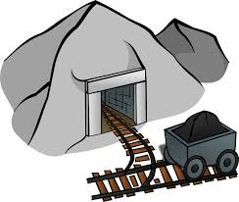
- An economy that is based on mining or producing

raw materials to be used in foreign industries (other

countries) is called what?

- How did militarism (making the military stronger) contribute to (cause) an increase in imperialism?
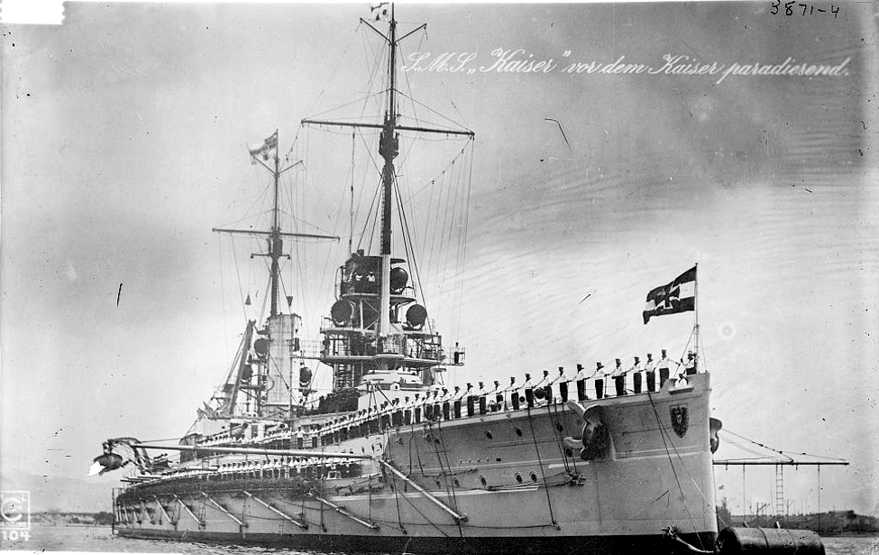

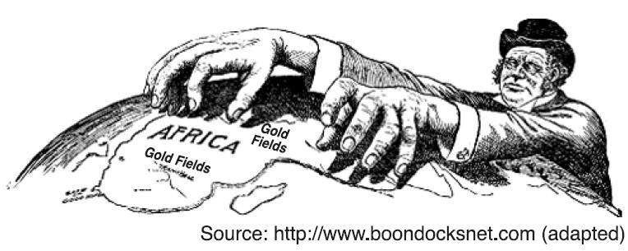

- Imperialism was the policy in which strong nations?

- What happened within a year of U.S. Navy Commodore Matthew Perry’s arrival in Tokyo Bay in 1853?
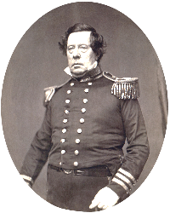
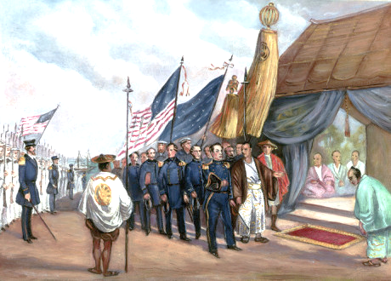

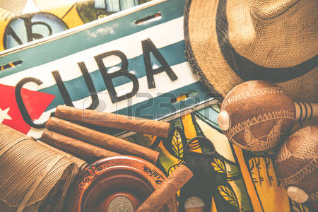
- Describe the Teller Amendment.

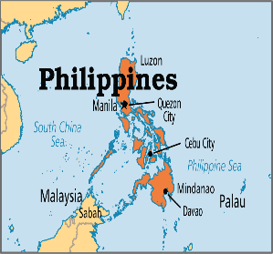
- Spain gave the U.S. full control of the Philippines when what happened?

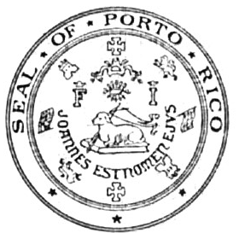
- After the Spanish-American War, Cubans and Puerto Ricans wanted what?

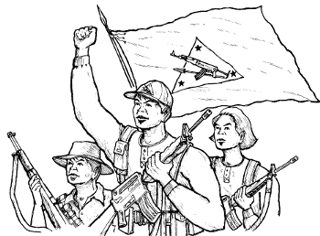
- Because U.S. forces had more guns, Filipinos who fought against American rule in the Philippines used what tactic?

- What happened in 1916, Congress passed The Jones Act?
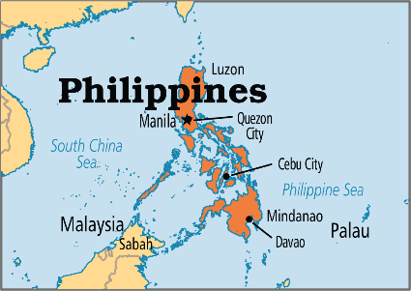

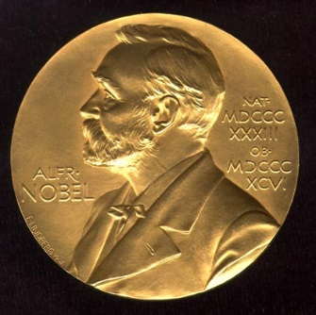
- Why did Theodore Roosevelt win the Nobel Peace Prize?

- How did the U.S. get access to (get to use) the Canal Zone in Panama?
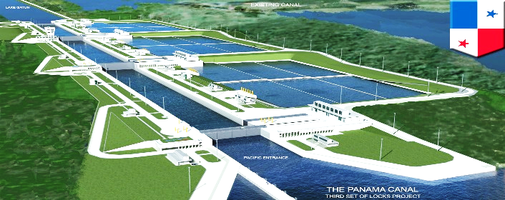

- What event was driving up the number of subscriptions for this newspaper (What was making people buy more of this newspaper) ?
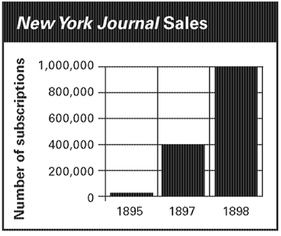

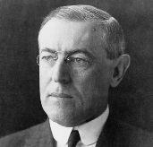
- “Moral diplomacy” means that the U.S. government should have done what?

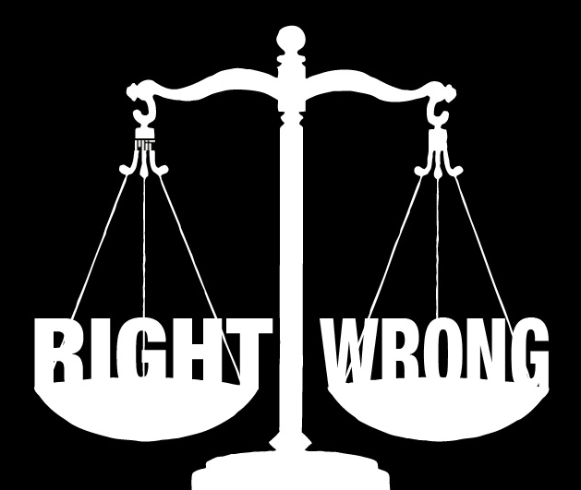
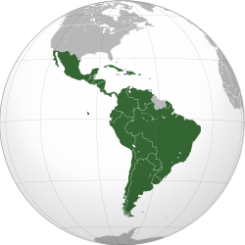

- Describe the Platt Amendment.

- America’s Open Door Policy in China was designed to do what?
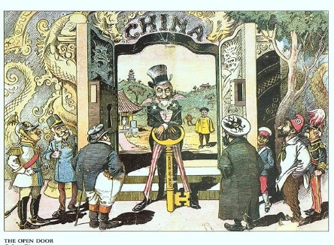

- When Filipinos rebelled (fought) against U.S. rule, the U.S. did what in response?

- At the conclusion of the Spanish-American War, what did the U.S. get?
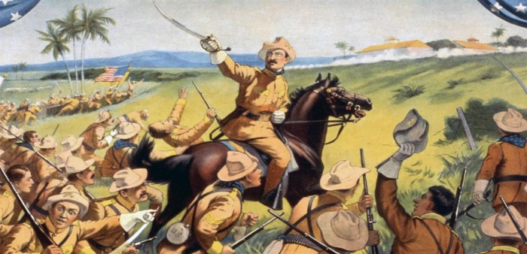

- Which presidential candidate ran on an anti-imperialist platform?
against

- Why did U.S. Navy Commodore George Dewey attack ships in the Manila Bay (Philippines) during the Spanish-American War?
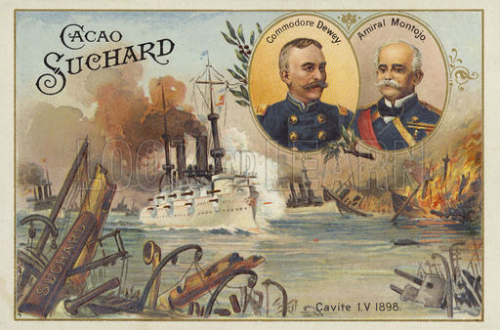

- What new relationship with Hawaii did Congress approve in 1898?
