Chapter 3 Study Guide
Key terms, people, and places to know
Directions: Using your notes, textbook, or the PowerPoints from our class website (https://mrkay.weebly.com/8th-grade-social-studies.html) write down important information about each of the terms, people, and places that may appear on the test.
cash crops
headright system
indentured servants
Toleration Act of 1649
John Smith
Jamestown
James Oglethorpe
Olaudah Equiano
Powhatan Confederacy
Boston
Anne Hutchinson
Immigrants
Pilgrims
Fundamental Orders
Mayflower Compact
Puritans
William Penn
Southern Colonies
Middle Colonies
New England Colonies
assemblies
colonial courts
English Bill of Rights
Enlightenment
free enterprise
French
French and Indian War
Great Awakening
Pontiac’s Rebellion
Middle Passage
Parliament
Sugar Act
Tea Act
Paul Revere
Samuel Adams
Boycott
Stamp Act
Intolerable Acts
Boston Massacre
Boston Tea Party
Questions to answer
How did the Powhatan people play in role with the Jamestown colony?
Why did the Stamp Act of 1765 anger the colonists so much?
What was the main result of the French and Indian War?
Why was the Toleration Act of 1649 important to the colonist’s development?
How did women specially contribute to colonies’ economies?
What were the point of views of many New England colonists on education?
What was Anne Hutchinson’s main belief that infuriated Puritan church leaders?
The English Bill of Rights reduced the powers of the English monarch while do what?
Be able to answer questions based on the information below
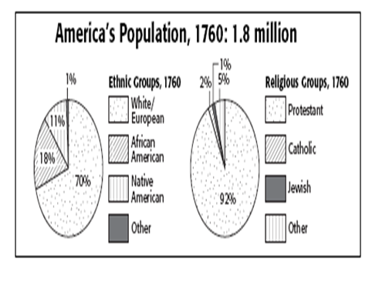
What middle colony was originally founded by the Dutch, but later taken over by the English?
What job did women in the middle colonies not be able to hold?
What is the term for crops that are always needed?

