Chapter 12 Study Guide Part 2
How can Congress override a presidential veto?

What must happen before a bill can be sent to the President for approval?

What happens to a bill in the House after a third reading and final vote of approval?

How can a majority of members of the House force a bill to the floor that has been buried in committee?

What happens to most bills that are referred to committees?

What does a House member do before proposing a new bill?

Members of the House and Senate may form a committee to work together on a certain issue such as taxation or the economy. What type of committee is this?

The Senate Watergate Committee investigated a scandal surrounding President Nixon in 1973. It is an example of which type of committee?

Describe select committees

Which standing committee in the House decides how to raise money for the federal government?

Why are committee chairmen important in the legislative process?

What is an important factor in the selection of committee chairmen?

What do party whips do?

What are the titles of the presiding officers of the House and the Senate?

What makes opening day in the Senate different from opening day in the House?

Describe this political cartoon
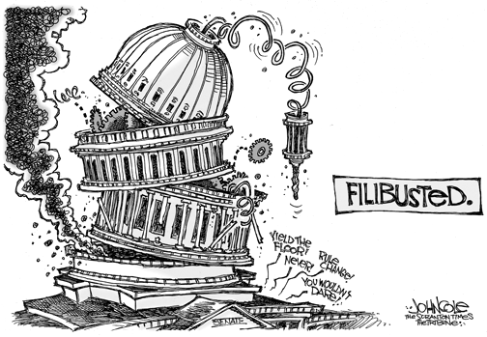
How is a bill introduced in the Senate?
After a bill comes out of a standing committee, what is the next step in getting it to the floor of the House for consideration?
Why is the House Rules Committee so powerful?

