Chapter 9 and 10 Study Guide
Merchants in Mecca were hostile to Muhammad because they thought what?

Muslim mystics who sought communion with God through meditation and fasting were called

When Muslims conquered a new land, they often did what

Akbar the Great helped to unite the Mughal empire by

At the bottom of Ottoman society were the

One reason for conflict between the Ottoman and Safavid empires was that

According to Muslim belief, Muhammad became the prophet of Islam after he
Muslims believe the sacred word of God as revealed to Muhammad is contained in the

Mecca became the holiest city in Islam because that is where Muhammad

How do the beliefs of Shiite and Sunni Muslims differ?

What helped the Umayyad caliphs to expand their empire?

By the eighth century, many Muslims criticized the Umayyad caliphs because the caliphs

Between 750 and 1350, what helped a prosperous system of international trade to develop in the Muslim world?

How did the famous Persian physician Ibn Sina (Avicenna) improve the practice of medicine?

In what way did the Delhi sultanate affect India?

Many lower-caste Hindus in India converted to Islam because

Akbar the Great helped to strengthen the Mughal empire by

In 1453, after defeating the Byzantines, the Ottomans moved their capital to

In Ottoman society, the men of the sword were almost exclusively

Shah Abbas brought thousands of Armenians to his capital at Isfahan because he wanted

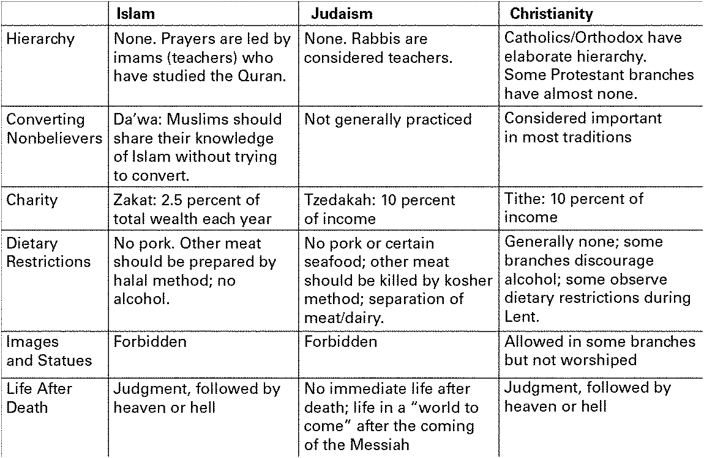

1. Make Comparisons Which characteristics of Islam shown in the table are similar to Judaism? Which are more like Christianity? Why are there similarities among the three religions? Explain.

Synthesize Information Describe the centers of learning in the Muslim world. How did Islam influence the development of these centers?

Make Generalizations How did diverse peoples of various religions, such as Christians and Jews, fit into Ottoman society? Did these peoples strengthen or weaken the empire?

Demonstrate Reasoned Judgment Why is Akbar considered to be one of India’s greatest rulers?

Ogier Ghiselin de Busbecq was ambassador of the Holy Roman emperor to the Turkish sultan’s court in Constantinople from 1555–1562.

No distinction is attached to birth among the Turks . . . in the public service. There is no fighting for precedence; a man’s place is marked out by the duties he discharges. In making his appointments the Sultan pays no regard to any pretensions on the score of wealth or rank, nor does he take into consideration recommendations or popularity, he considers each case on its own merits, and examines carefully into the character, ability, and disposition of the man whose promotion is in question. It is by merit that men rise in the service, a system which ensures that posts should only be assigned to the competent. . . . Among the Turks, therefore, honours, high posts, and judgeships are the rewards of great ability and good service.
—Ogier Ghiselin de Busbecq, The Turkish Letters, 1555-1562

Analyze Information Read the passage. What does it tell us about Ottoman policies toward government appointments and promotions? How might these policies have helped to create a strong government?

Recognize Ideologies How did class differences among Indians contribute to the development of Sikhism?

Summarize How did the Umayyad caliphate treat non-Muslims in conquered lands? Explain your answer.

