**Big 3 Warm Up 10/08/15**

**Word of the Day:**

**Immigrant**

Definition: A person who leaves one country to settle permanently in another.

EXAMPLE SENTENCE:

After a journey that could range from a week to several months, the immigrants would arrive in New York City, Boston, Philadelphia, Galveston, or another American port.

Please write a sentence using the word of the day. Underline the word of the day in your sentence.

**History/Government Trivia:**

What is the name of the author who wrote, Give me your tired, your poor, your huddled masses yearning to breathe free." in the Poem *The New Colossus* in 1883?

**Picture Response:**

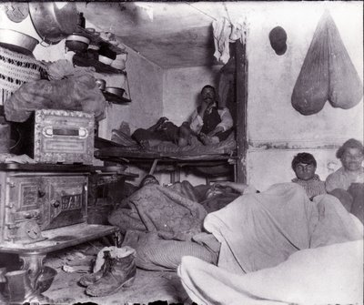

Emma Lazarus