**Special Edition Big 3 Warm Up for Monday and Tuesday November 20th and 21st**

Words of the Day:

**Feast**

# Definitions:

# 1. A ceremonial dinner party for many people

# 2. Something experienced with great delight

Use the word of the day in a sentence and underline the word.

**Pilgrim**

Definitions

1. Someone who journeys in foreign lands

2. Someone who journeys to a sacred place as an act of religious devotion

Use the word of the day in a sentence and underline the word.

**Trivia:**

1. **President Roosevelt preponed Thanksgiving one week to stabilize the economy during the Great Depression in 1939. Who opposed the following change?**
2. **What was the name of the ship that the pilgrims came over on?**
3. **What Native American tribe was invited to spend Thanksgiving with the pilgrims?**
4. **What vegetable did the pilgrims have available for Thanksgiving but did not use because they thought it was poisonous?**
5. **The original Thanksgiving lasted how long?**
6. **Thanksgiving is only celebrated in the United States. True or False? If False, what other country celebrates it?**

**Picture Responses:**

**A)**

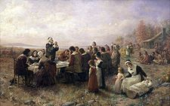

**Write a two to three sentence interpretation of this historic painting**

B)

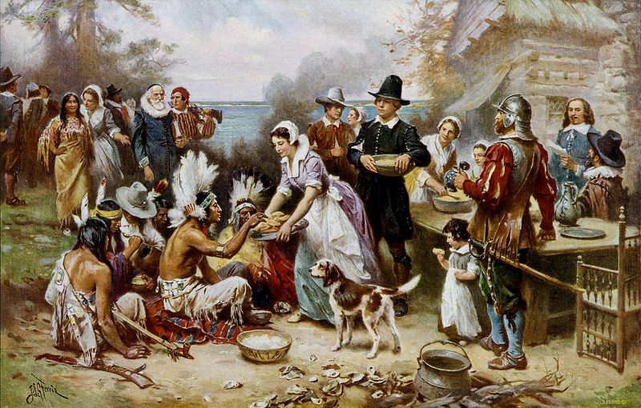

**Write a two to three sentence interpretation of this historic painting**

<http://www.buzzle.com/articles/thanksgiving-trivia-questions-and-answers.html>