**Big 3 Warm Up 2/25**

**Word of the Day:**

[**Barter**](http://www.vocabulary.com/dictionary/barter)

Definition: exchange goods without involving money

EXAMPLE SENTENCE:

However, a great deal of diplomacy in establishing allies, **bartering** land, and signing peace treaties was necessary for each warring state, and the idealized role of the "persuader/diplomat" developed.

Please write a sentence using the word of the day. Underline the word of the day in your sentence.

**World History/Government Trivia:**

What U.S. President pardoned Robert E. Lee posthumously of all crimes of treason?

**Picture Response:**

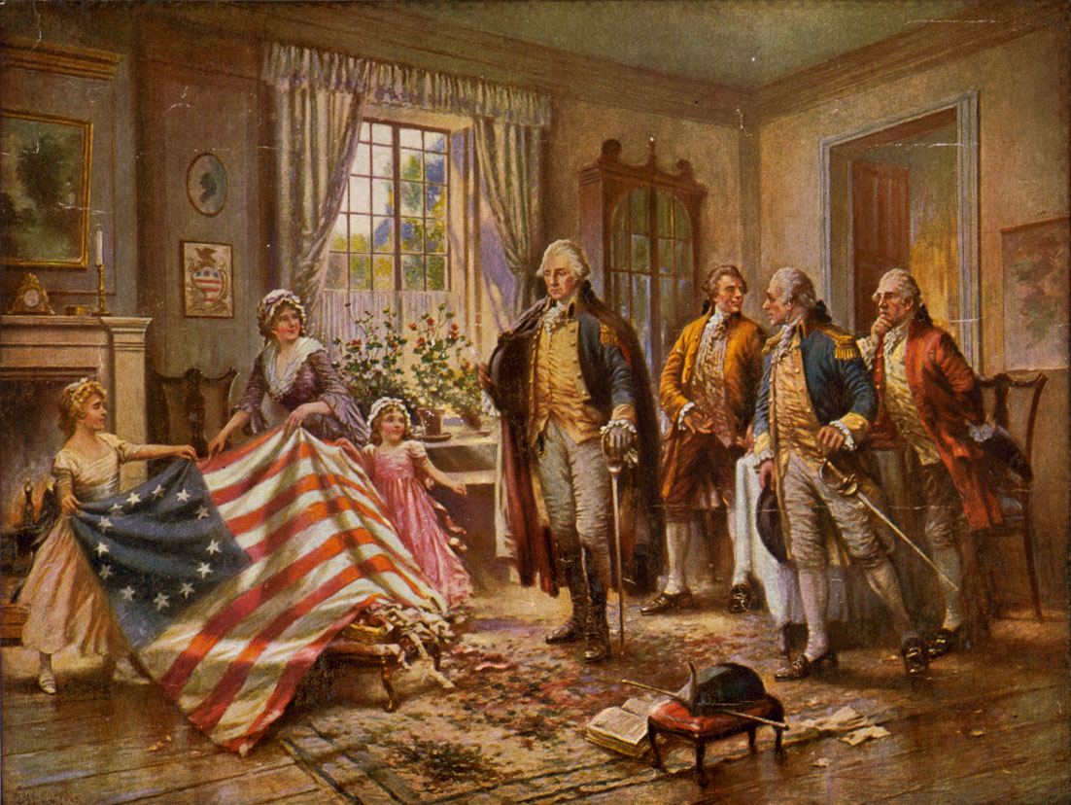

Your response must be at least two sentences in length.

Gerald Ford