Big 3 Warm Up September 29th

Word of the Day:
Rubric, noun:
Definitions:
1. A title, heading, or the like, written or printed in red or otherwise distinguished from the rest of the text.
2. A direction for the conduct of divine service.
3. Any established mode of conduct or procedure.

Example Sentence: In our office, we have a file of rubrics The New Yorker has used in its eighty-five-year history

In order to receive full credit, you must create your own sentence using the word of the day. You must underline the word of the day in your sentence.

American History/Government Trivia:

Louisa (blank), wife of a U.S. President, was the first (and only) foreign-born first lady. Who was she the wife of?

Picture Response:

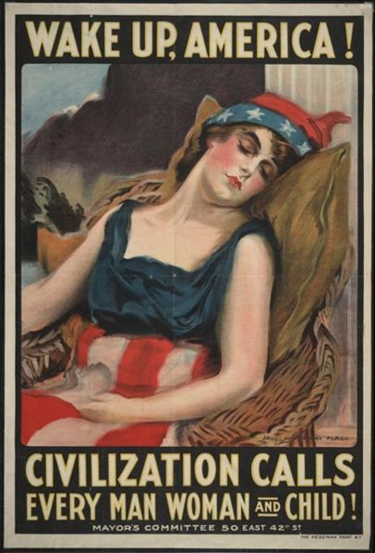

Write a two to three sentence interpretation of this historic painting

Quote of the Day:
“Actions speak louder than words.”

John Quincy Adams

