Big 3 Warm Up September 27th

Word of the Day:

Collateral (noun)

Definition: Money or resources offered in exchange for a loan.

Example Sentence: At the bank, the farmer put forth his herd of cows as collateral for a loan that would enable him to update his barn.

In order to receive full credit, you must create your own sentence using the word of the day. You must underline the word of the day in your sentence.

American History/Government Trivia:
All three major (blank) Presidential candidates, Clinton, Dole and Perot, were left-handed. What year did all three of them run for the presidency?

Picture Response:

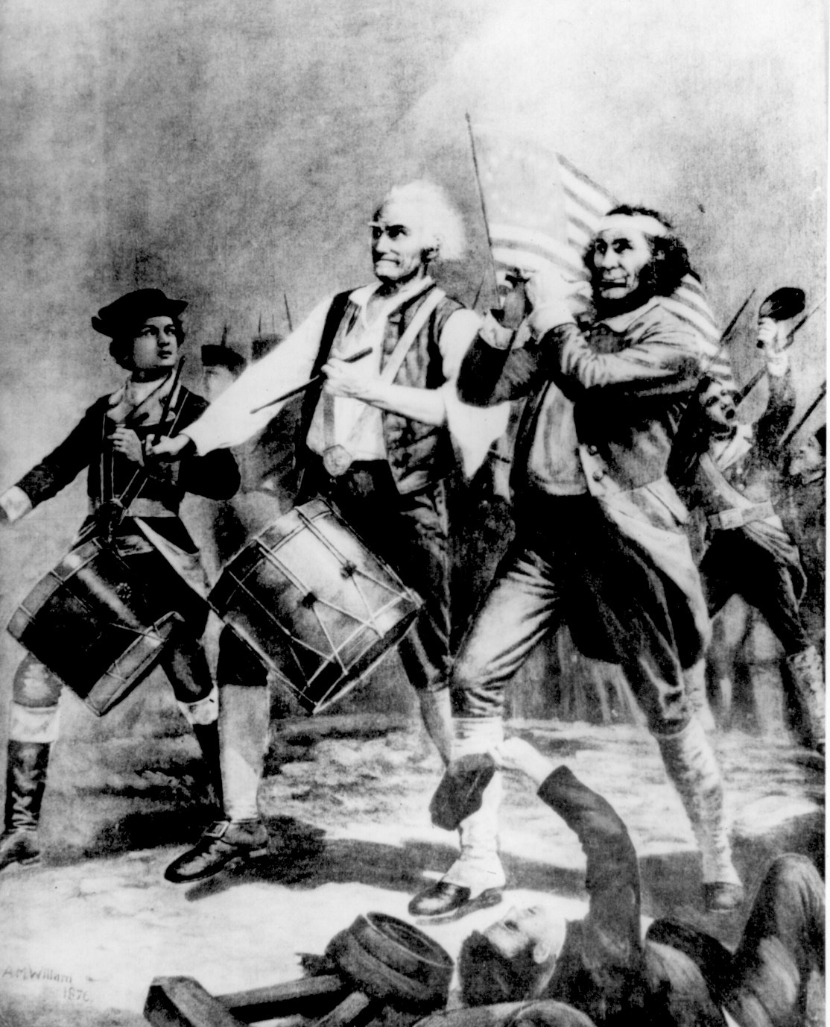

Write a two to three sentence interpretation of this historic painting

1996

Quote of the Day:
“Actions speak louder than words.”

