Big 3 Warm Up September 26th

Word of the Day:

Irreverent (adj)

Definition: Lacking proper respect.

The child was wholly irreverent: she stuck out her tongue at the minister and yelled names at her grandparents.

In order to receive full credit, you must create your own sentence using the word of the day. You must underline the word of the day in your sentence.

American History/Government Trivia:
Antonia ('Tonie') Nathan, the 1972 Vice-Presidential candidate of the (blank) Party, was the first woman in American history to receive an electoral vote. Which political party did she belong to?

Picture Response:

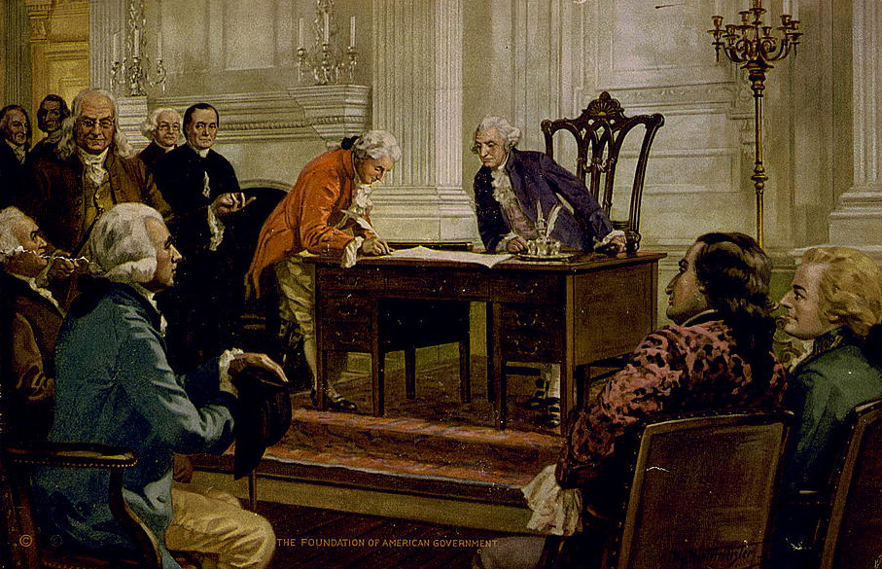

Write a two to three sentence interpretation of this historic painting

Quote of the Day:
“Actions speak louder than words.”

Libertarian Party

