Big 3 Warm Up 10/09

Word of the Day:

Definition:
Fabricate, verb:
1. To make, build, or construct
2. To make up, invent
3. To fake or forge a document or signature

Example Sentence: "I've had more people tell me that throughout my career: 'Man, we love to watch you play. Your enthusiasm and stuff like that.' I mean, it's not fabricated. I love to play the game …"

Use the word of the day in a sentence and underline the word.

8th Grade Social Studies Trivia:

- Of the 32 civil rights cases Thurgood Marshall argued before the U.S. Supreme Court as the lawyer for the National Association for the Advancement of Colored People, how many did he win?
- Where did Christopher Columbus voyage to in 1477?

Picture Response:
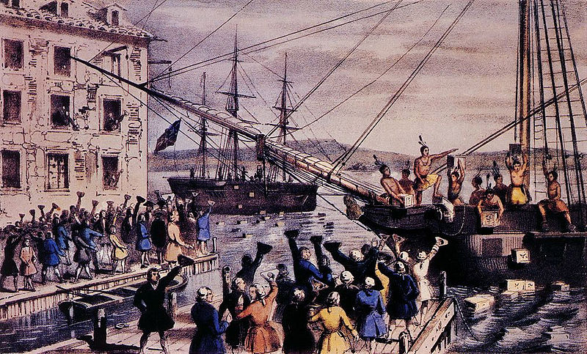

Write a two to three sentence interpretation of this historic painting

Quote of the Day:
“Actions speak louder than words.”

29

Columbus Visited Iceland in 1477
Fifteen years before he reached the New World, Columbus sailed to Iceland and visited a small Christian church on the Eastern end of the island. This piece of trivia may be the most surprising or controversial, but Iceland had been a Christian nation, since the eleventh century, when Leif Eriksson, (a Christian convert) had established the first church there. Going to Iceland was no big deal, as Catholic priests made the voyage from time to time on ships bound for Norway. Further evidence can be found in Columbus's journals, where he speaks about going to Tiles (the name used for Iceland at that time).

