Big 3 Warm Up 10/03

Word of the Day:

Acknowledge

Definition: Declare to be true or admit the existence or reality or truth of

EXAMPLE SENTENCE:
Napoleon also refused to acknowledge diplomatic immunity, imprisoning several British diplomats accused of scheming against France.

Please write a sentence using the word of the day. Underline the word of the day in your sentence.

8th Grade Social Studies Trivia:
Who was the first president to be born in a hospital?

Picture Response:

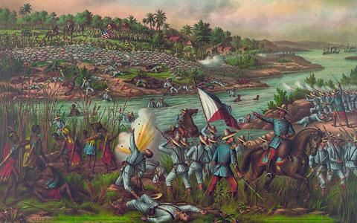

Write and two to three sentence response

Jimmy Carter

