Big 3 Warm Up 10/29

Word of the Day: Coalition

Definition:
1.The act of forming an alliance or confederation.

2. A formal agreement establishing an association or alliance between nations or other groups to achieve a particular aim or goal.

3. An organization of people (or countries) involved in a pact or treaty.

Example Sentence: Loyalist followers of the former dictator are accused of targeting Iraqis they perceive to be working with the U.S.-led coalition.

Use the word of the day in a sentence and underline the word.

World History/Government Trivia:
1. What two animals represent the two major political parties in America?
2. Who was the first president paid a salary of $100,000?

Picture Response:
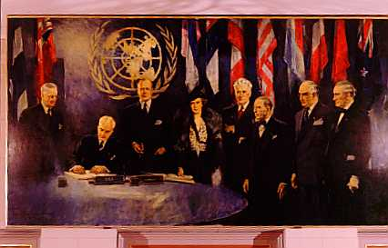

Write a two to three sentence interpretation of this historic painting

Quote of the Day:
“In our personal ambitions we are individualists. But in our seeking for economic and political progress as a nation, we all go up or else we all go down as one people.” Franklin D. Roosevelt

Answer for Trivia Questions:
Donkey(Democrats) and Elephant (Republicans)
Harry S. Truman

