Big 3 Warm Up 10/26

Word of the Day: Alias

Adverb

otherwise called : otherwise known as

Example Sentence: Samuel Clemens used the alias Mark Twain when he wanted to write books.

American History/Government Trivia

This holiday has a law in place so that no President can change the date after the national outrage caused one President to reverse his decision. Name the Holiday.

Picture Response

Write two to three sentences based off the historic painting.

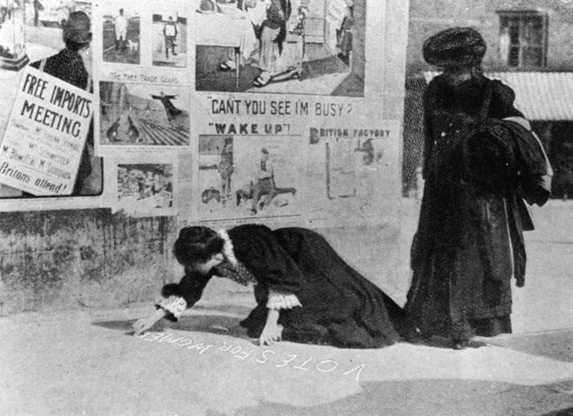

Quote of the Day

“Difficulty is the excuse history never accepts.”

Thanksgiving

