Big 3 Warm Up 10/12

Word of the Day:
Misprize, transitive verb:

Definition:
1. To hold in contempt.
2. To undervalue.

Example Sentence: I hesitate to appear to misprize my native city, but how can the history of dear, sedate old London town possibly compare to Paris for sheer excitement?

Use the word of the day in a sentence and underline the word.

8th Grade Social Studies Trivia:

Which American colony was the first to enact anti-slavery legislation?

Picture Response:

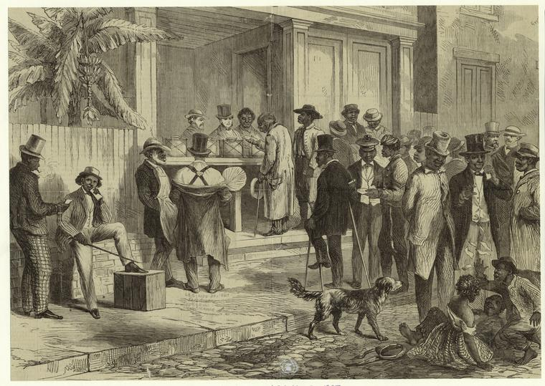

Write a two to three sentence interpretation of this historic painting

Quote of the Day:
“Actions speak louder than words.”

Massachusetts, in 1641, in its "Body of Liberties."

