Big 3 Warm Up 11/09

Word of the Day: Overhaul

Verb

1a : to examine thorough

b (1) : repair (2) : to renovate, remake, revise, or renew thoroughly

2: to haul or drag over

3: overtake

Ex: Lawmakers are overhauling the welfare program.

American History/Government Trivia

During the Second Party System of the United States, three men would go on to be considered the Great Triumvirate. Name the Three Men.

Picture Response

Write two to three sentences based off the historic image.

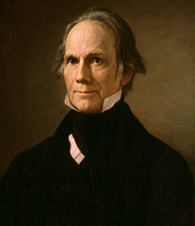

Quote of the Day

“The world moves, and ideas that were once good are not always good.”

John C, Calhoun, Daniel Webster, Henry Clay

