Big 3 Warm Up 11/09

Word of the Day: Antagonistic

Adjective

marked by or resulting from antagonism

showing dislike or opposition

Ex: They found it impossible to deal with such antagonistic groups.

8th Grade Social Studies Trivia

These two states have had the most presidents come from their borders. Name the states.

Picture Response

Write two to three sentences based off the historic image.
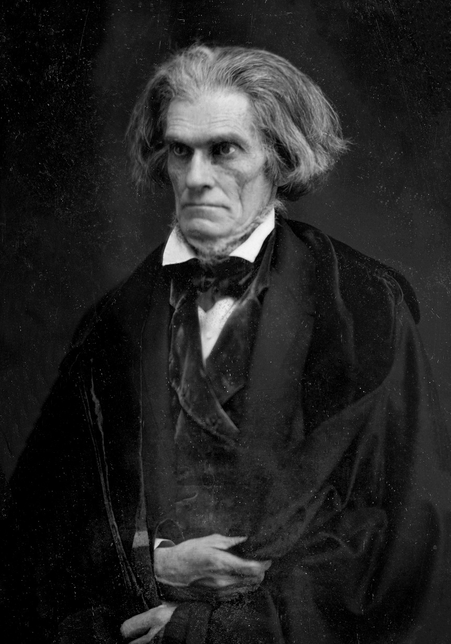

Quote of the Day
“The government is us; we are the government, you and I in the United States of America”

Ohio and New York

