Big 3 Warm Up 11/07

Word of the Day: Trite

Adjective

Not interesting or effective because of being used too often: not fresh or original

Example Sentence: Its wares are soiled with frequent handling; its styles are so hackneyed, trite, and homogeneous, they constitute a single style.

8th Grade Social Studies Trivia

This stuffed animal was created in 1902 after a famous politician and U.S. President refused to shoot a caged real life version of it. Who is the name of this animal?

Picture Response

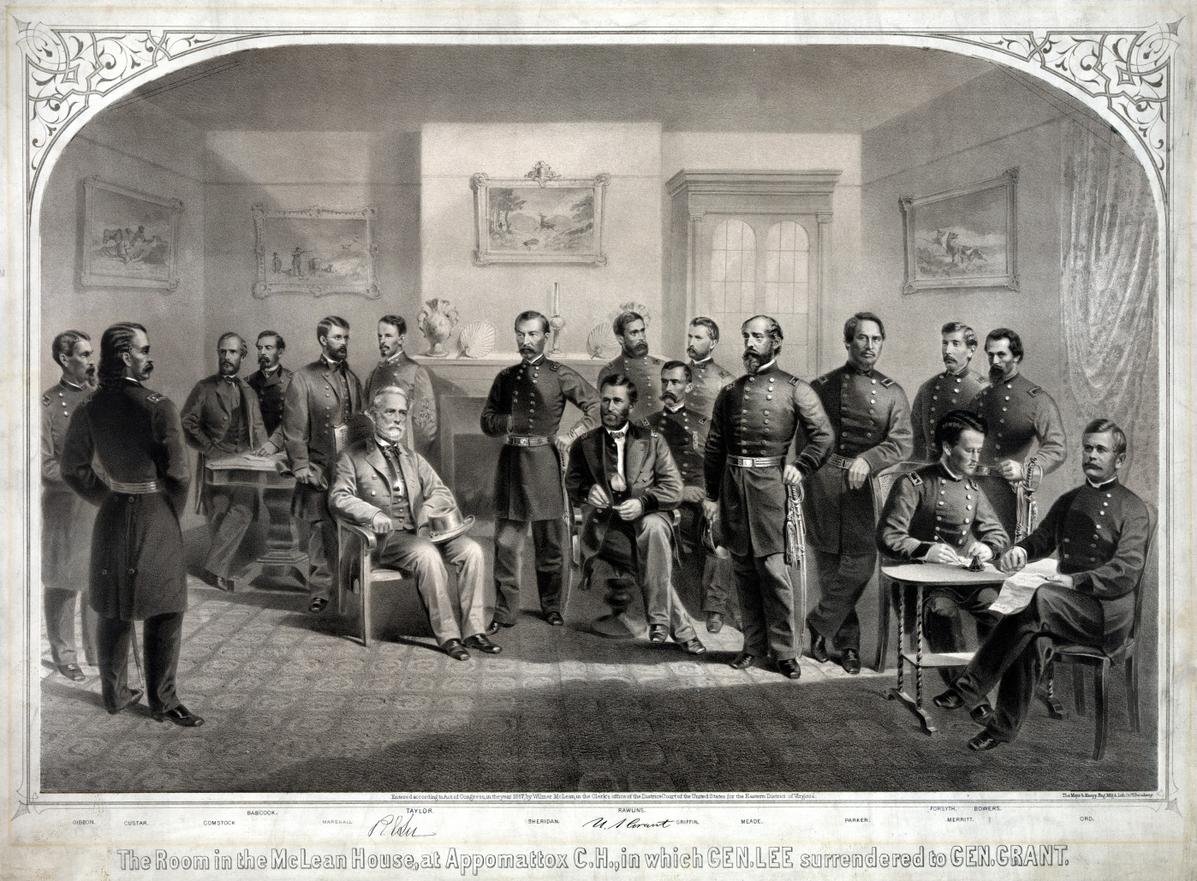
Write two to three sentences based off the historic painting.

Quote of the Day
“The best way to guarantee a loss is to quit.”

Teddy Bear

