Big 3 Warm Up 11/04

Word of the Day: Trite

Adjective

not interesting or effective because of being used too often : not fresh or original

Example Sentence: Its wares are soiled with frequent handling; its styles are so hackneyed, trite, and homogeneous, they constitute a single style.

World History/Government Trivia

This stuffed animal was created in 1902 after a politician refused to shoot a caged real life version of it.

Picture Response

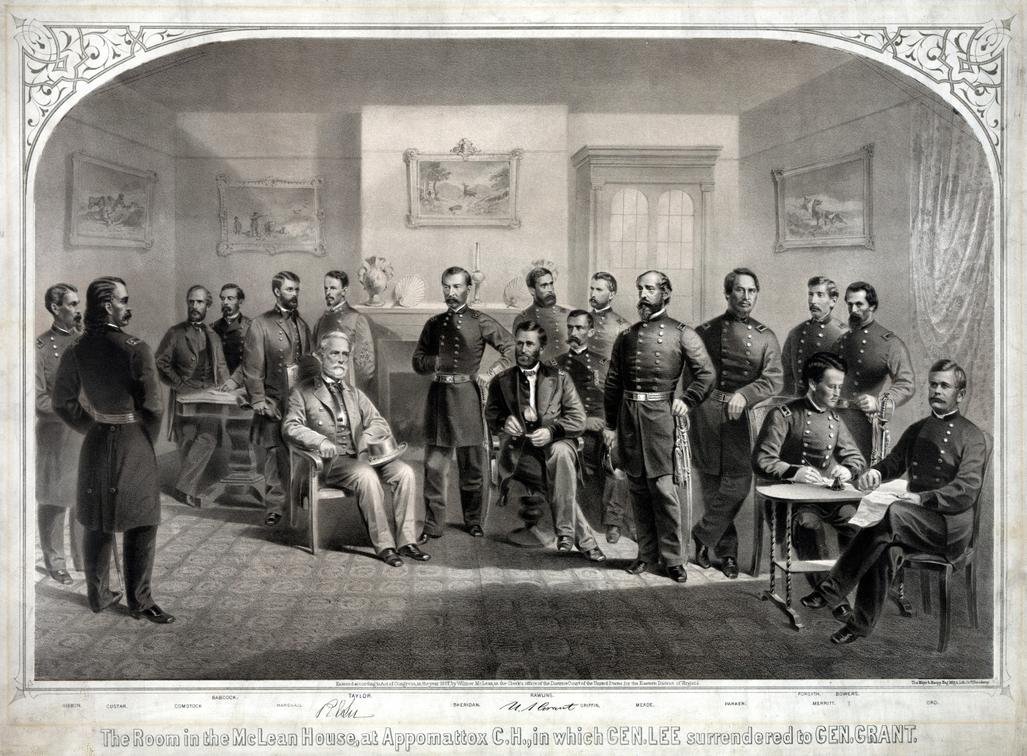
Write two to three sentences based off the historic image.

Quote of the Day
“The best way to guarantee a loss is to quit.”

Teddy Bear

