Big 3 Warm Up 11/02

Word of the Day: Noxious
Adjective

1a : physically harmful or destructive to living beings <noxious waste>
b : constituting a harmful influence on mind or behavior; especially : morally corrupting <noxious doctrines>
2: disagreeable, obnoxious

Example Sentence: The old theory of paludism or of a noxious miasma exhaled from the ground is no longer necessary

World History/Government Trivia

This state gave the world the first State Police Radio Program in 1929, what is the state?

Picture Response

Write two to three sentences based off the historic painting.
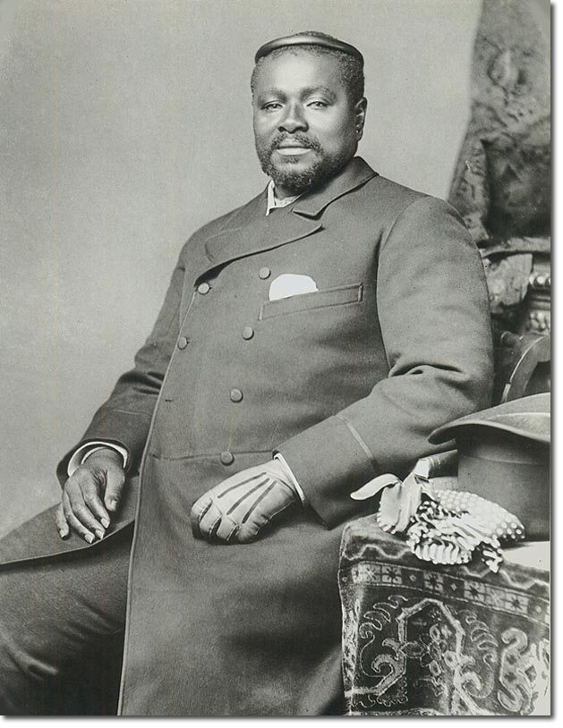

Quote of the Day
“The educated differ from the uneducated as much as the living from the dead.”

Michigan

