Big 3 Warm Up 11/01

Word of the Day: Adversity
Noun

Definition: A state or instance of serious or continued difficulty or misfortune

Example Sentences:
The movie is about a group of determined mountain climbers who triumph in the face of adversity.

"In this way, [the movie] 'It' was meant to reflect how our childhood experiences and fears influence the people we become, and how our adult selves use that to deal with adversity."

8th Grade Social Studies Trivia

Name the four flags that have flown over Michigan’s Soil in order from First to Last.

Picture Response

Write two to three sentences in response to what you see below.
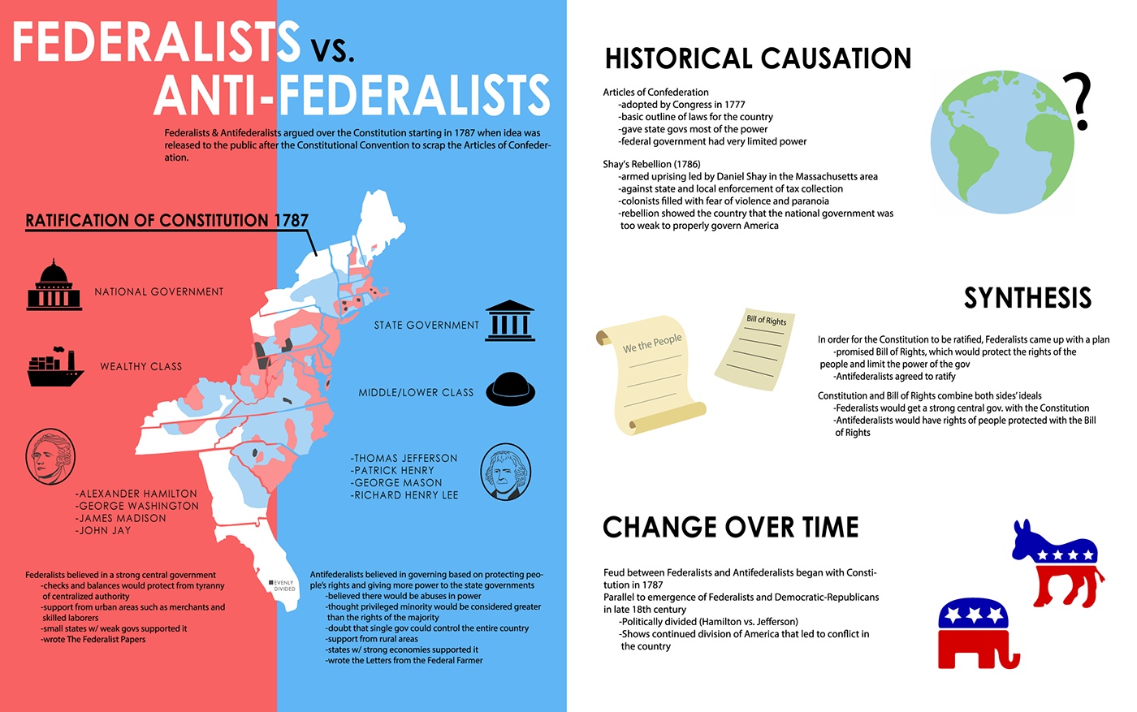

Quote of the Day
“All people by nature desire knowledge. “

French, Spanish, English, American

