Big 3 Warm Up 5/08

Word of the Day:
Finesse • noun
Definition: skillful handling of a situation

Example Sentences and Video:
The winner of the chess match displayed his finesse in the game by beating his opponent in less than fifteen minutes.
The medical students watched in amazement as the brilliant surgeon performed the operation with great finesse.
https://www.youtube.com/watch?v=TQUYd8-fc94

8th Grade Social Studies Trivia:

Question 1: On July 16, 1945, three weeks before the atomic bomb was dropped on Hiroshima, it was tested for the first time where?
Question: 2: Abraham Lincoln was born, raised, and practiced law in three different states. Which ones?

Picture Response:

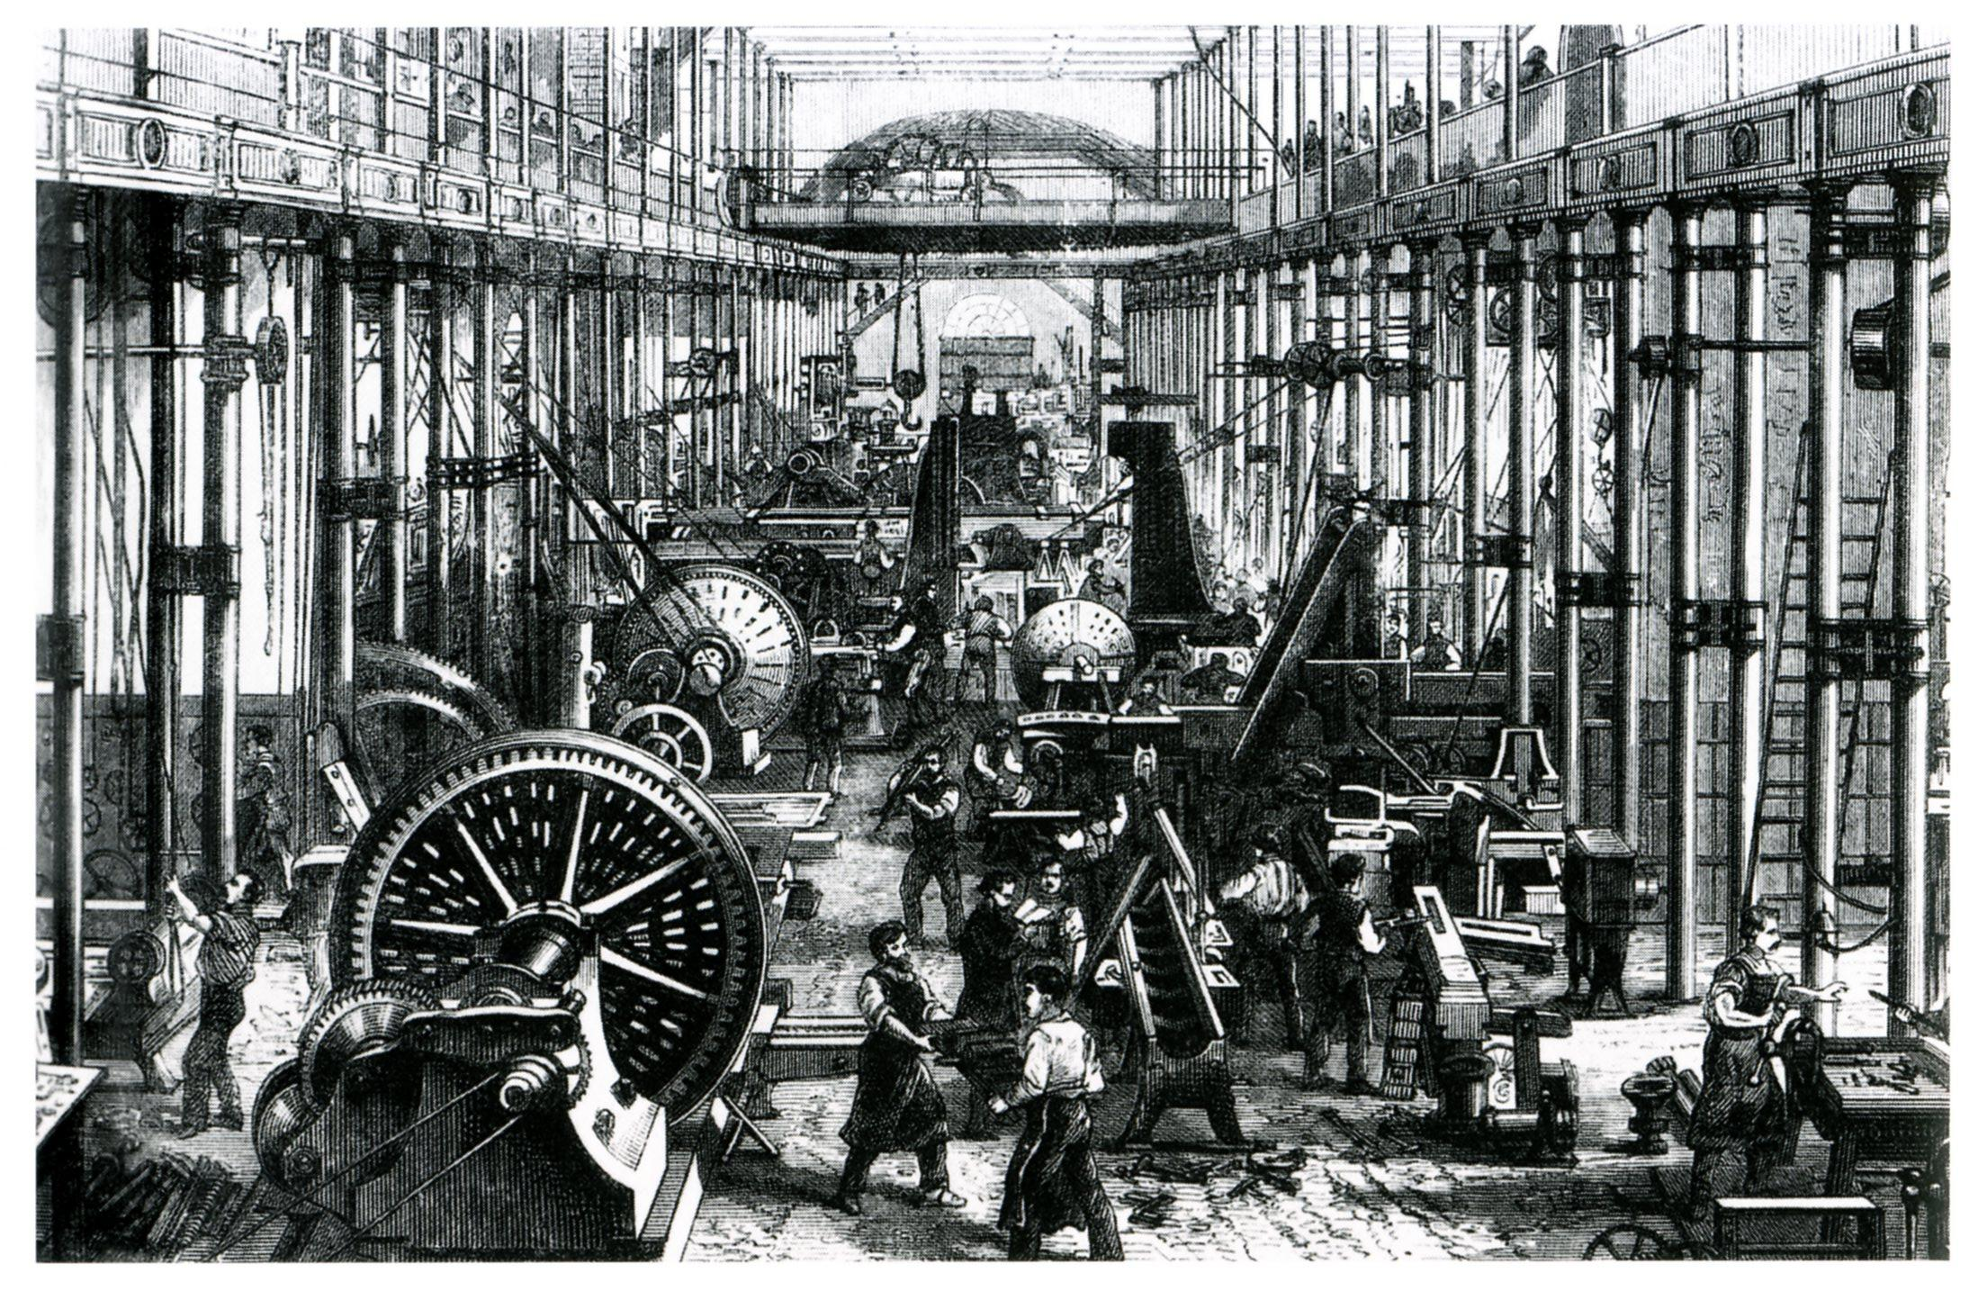

NEW MEXICO at the White Sands Missile Range

Kentucky from birth to 7 / raised in Indiana from age 7 to 21 / lived as an adult and practiced law in Illinois, from 1847 to 1859, and become a senate nominee in 1858.

