Big 3 Warm Up 5/07

Word of the Day:

Dishearten • verb
Definition: Take away the enthusiasm of

Example Sentence and Video:
Mr. Kay was dishearten by the lack of essays that were turned into him today in class.

https://www.youtube.com/watch?v=scTP4F2MwDU

8th Grade Social Studies Trivia:

Question 1: According to the U.S. Constitution, no person may become President of the United States unless he/she is a citizen who has lived in this country for at least how many years?
Question: 2: There have been about three occasions when the person who was elected President of the United States actually had fewer popular votes than the loser, but won because of electoral votes. One time that this happened was in 1888, when Grover Cleveland lost who beat him?

Picture Response:

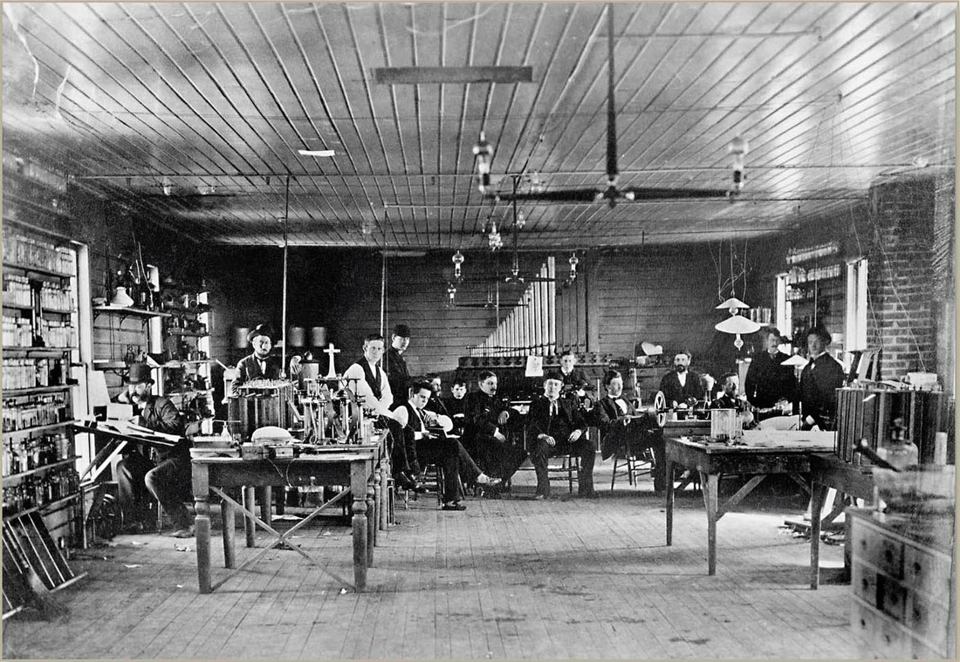

14 YEARS
BENJAMIN HARRISON

