Big 3 Warm Up 5/13

Word of the Day:

Trivial

Adjective

Definition

1 a: of little worth or importance

b: relating to or being the mathematically simplest case; specifically : characterized by having all variables equal to zero

2: commonplace, ordinary

3: of, relating to, or constituting a species and especially a biological species

Example: A paper published in the Journal of Experimental Psychology examined how pettiness—being intentionally attentive to trivial details.

8th Grade Social Studies Trivia:

Question 1: Was Thomas Edison the first to receive a patent for the electric light bulb?
Question: 2: When did the dishwasher become the labor-saving machine that it is today?

Picture Response:

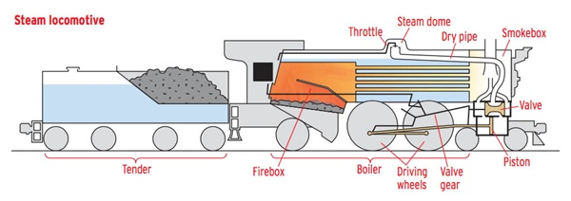

Write a two to three sentence interpretation of this picture
Quote of the Day:
“If I have the belief that I can do it, I shall surely acquire the capacity to do it even if I may not have it at the beginning.”
-Mahatma Gandhi

- No, he wasn't, but his documentation proved he was the first to invent it. Competitors had heard about his light bulb project and quickly applied for and received patents. Edison presented his extensive and detailed documentation in a lawsuit for patent infringement and won the case.
- Unfortunately, the first dishwasher, patented in 1850, was not very effective. The invention consisted of a hand-turned wheel that splashed water onto dishes. The first working automatic dishwasher was invented by Josephine Garis Cochran in 1889. Her machine featured a wooden tub that included a wire basket. Dishes were placed inside the basket, and rollers rotated the dishes. Hot, soapy water sprayed into the tub and cleaned the dishes as a handle on the tub was turned. Cochran first displayed her machine at the World's Fair in Chicago in 1893 and sold dishwashers to restaurants and hotels.

