**Big 3 Warm Up 03/09**

**Word of the Day: Suasion** \SWAY-zhun\ , *noun*:

Definition:

**1.**  The act of persuading  
**2.**  Persuasion

Example Sentence:

He visualized a world wherein power is exercised peacefully by moral **suasion**and political acumen, a world of idealism in many ways.

Use the word of the day in a sentence and underline the word.

**World History/Government Trivia:**

1. Who was Vice President during WWI?

2. How much did President Roosevelt pay so that the Panama Canal could be built?

**Picture Response:**

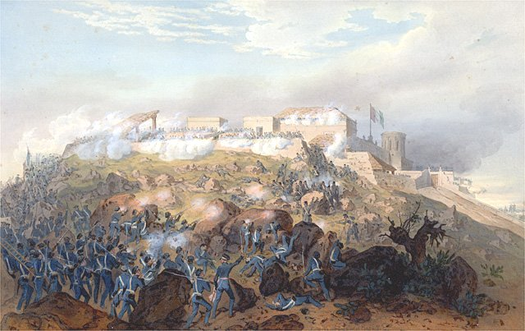

**Write a two to three sentence interpretation of this historic painting**

**Quote of the Day:** “Actions speak louder than words”

**Answer Trivia:**

A: Thomas R Marshall.

A: $40 million.