Big 3 Warm Up 3/18

Word of the Day:

Discretion •noun
1. the power of making free choices unconstrained by external agencies
2. freedom to act or judge on one’s own
3. the trait of judging wisely and objectively
4. knowing how to avoid embarrassment or distress
5. refined taste; tact
Underline the word and use it in a sentence

World History/Government Trivia:
This President was the first American President to win the Nobel Peace Prize. He won for his arbitration of treaty discussions at the end of the Russo-Japanese War.
Who am I referring to?

Picture Response:

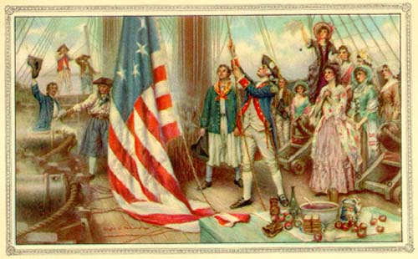

(Example of student response)
Responses will vary

Quote of the School Year:
“Actions speak louder than words.”

Theodore Roosevelt

