Big 3 Warm Up 03/15

Word of the Day: Shamrock

Noun

Definitions:

A low-growing clover-like plant with three-lobed leaves, used as the national emblem of Ireland.

A shamrock leaf.

Example Sentence:
“Four leaf shamrocks are to some people a sign of luck.”
Use the word of the day in a sentence and underline the word.

8th Grade Social Studies Trivia:

- The first St. Patrick’s Parade was held in 1762, which city held the parade?
- St. Patrick’s color of choice was actually a light shade of what color?
The whole green tradition came along when the independence movement in the 18th century used a flag of the bright green color.

Picture Response:

Write a two to three sentence interpretation of this historic picture and or painting

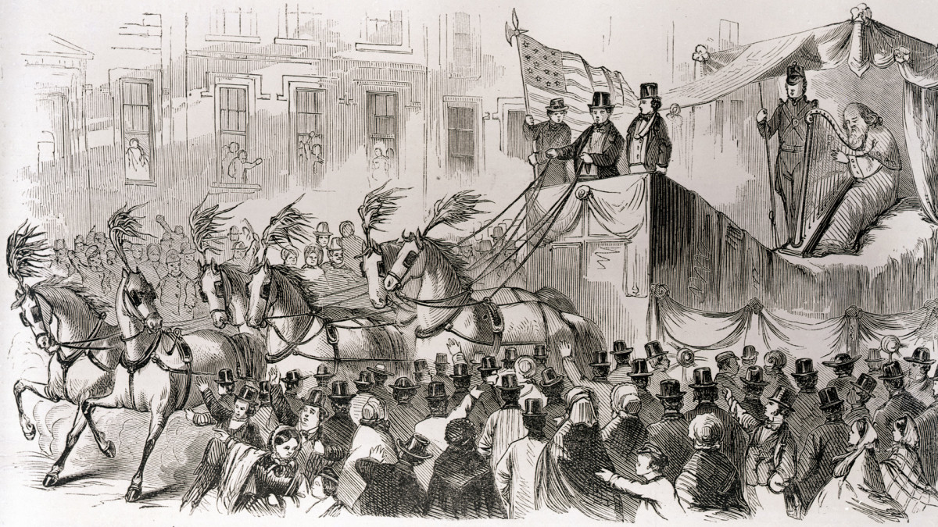

Quote of the Day: “The best thing about the future is that it comes only one day at a time.”
- Abraham Lincoln

A. New York
A. blue called “St. Patrick’s blue.”

