Big 3 Warm Up 3/11

Two Words of the Day:

Discretion •noun
1. the power of making free choices unconstrained by external agencies
2. freedom to act or judge on one’s own
3. the trait of judging wisely and objectively
4. knowing how to avoid embarrassment or distress
5. refined taste; tact
Supersede * verb
1. To replace in power, authority, effectiveness, acceptance, use, etc., as by another person or thing.
2. To set aside or cause to be set aside as void, useless, or obsolete, usually in favor of something mentioned; make obsolete:
Underline the word and use it in a sentence

8th Grade Social Studies Trivia:
This politician was the first African American woman elected to Congress and in 1972 became the first major-party African American candidate for president, what was her name?
A. Mahalia Jackson
B. Angela Davis
C. Shirley Chisholm
D. Mary McLeod Bethune

Picture Response:

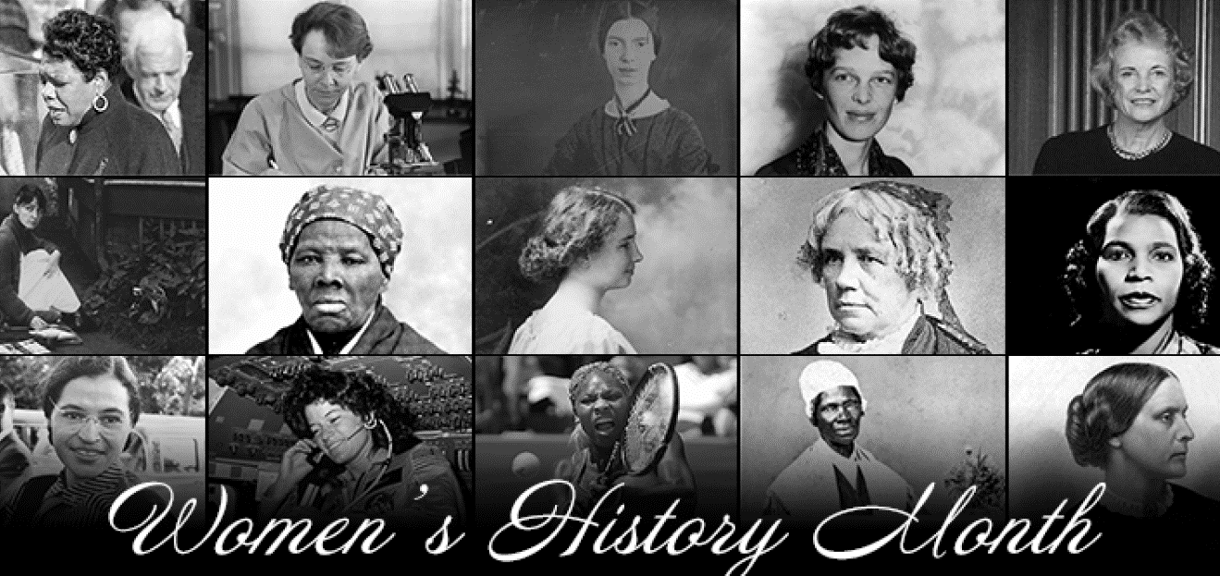

(Example of student response)
Responses will vary

Quote of the School Year:
“Actions speak louder than words.”

Shirley Chisholm

