Big 3 Warm Up 01/09/19

Word of the Day: UNDERSTATE

Definition(s):
To play down the significance of something
Example Sentence:
"Because the student had understated how badly he was doing in school, his parents were surprised by his appalling report card."

Use the word of the day in a sentence and underline the word.

8th Grade Social Studies Trivia:
"We hold these truths to be self-evident, that all men are created equal..." is written in which document?
a. The Constitution
b. The Declaration of Independence
c. The Bill of Rights

8th Grade Social Studies Trivia
All of the following factors contributed to significant growth in worldwide population from 1750 through 1900 EXCEPT
(A) decline of epidemic disease
(B) introduction of Western Hemisphere food crops to new areas
(C) expansion of land under cultivation
(D) new grain crops developed in the Green Revolution

Picture Response:

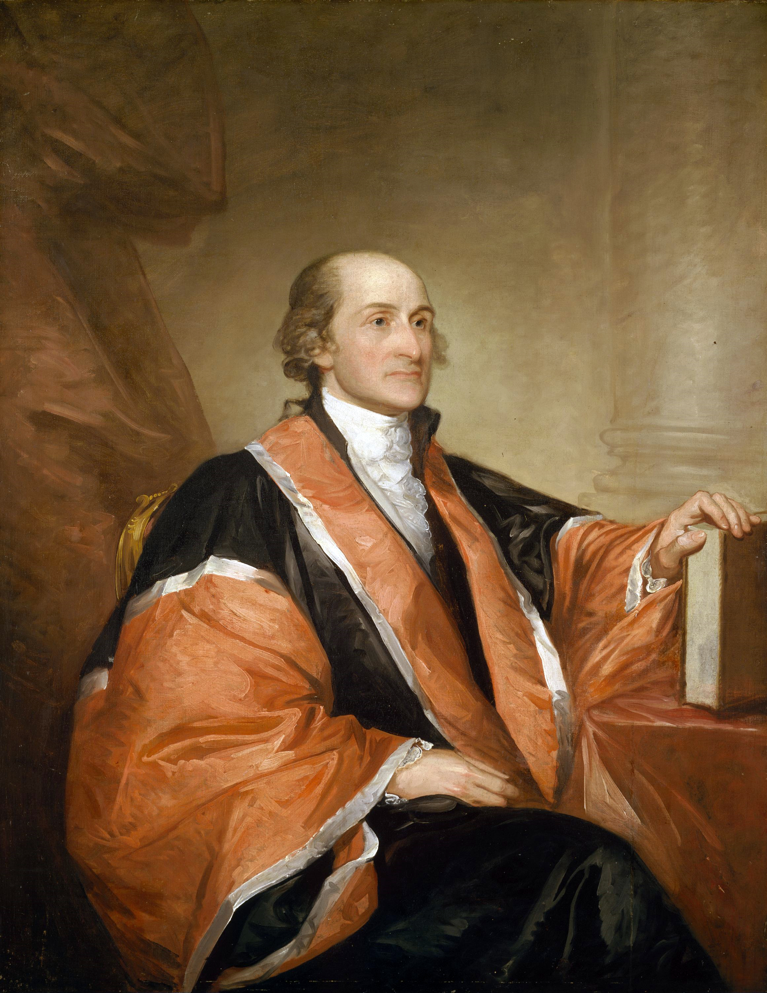

Write a two to three sentence interpretation of this painting

Quote of the Week:
“Preparation and the willingness to review and study for an upcoming exam is the key to success.”
- Mr. Kay

A: b. The Declaration of Independence

A: D. new grain crops developed in the Green Revolution

