Big 3 Warm Up for January 23rd

Word of the Day: Gargantuan

Adjective

Definition

: Tremendous in size, volume, or degree: gigantic, colossal
Example Sentence:
Due to our gargantuan scope, Houston is a haven for live music. As the nation's fourth largest city, we have become a destination for touring acts

Use the word of the day in a sentence and underline the word.

8th Grade Social Studies Trivia:
Where did Martin Luther King Jr study and receive his doctorate of divinity degree?
A. Boston University
B. Harvard Divinity School
C. Duke Divinity School

Picture Response:

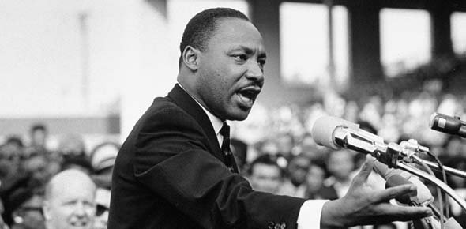

Write a two to three sentence interpretation of this painting

Quote of the Week:
“Preparation and the willingness to review and study for an upcoming exam is the key to success.”
- Mr. Kay

A: Boston University

