Big 3 Warm Up for 01/22

Word of the Day:
Mea Culpa

Noun

Definition(s):
: A formal acknowledgment of personal fault or error

Example Sentence:
"The internal investigation ended with a mea culpa from the sheriff's department and a reprimand and reassignment for a deputy overseeing the case.
Use the word of the day in a sentence and underline the word.

8th Grade Social Studies Trivia:

Where did Martin Luther King Jr. deliver his famous “I Have a Dream” speech?

A. Lincoln Monument in Washington, D.C.

B. Courthouse in Montgomery, Ala.

C. Ebenezer Baptist Church in Atlanta, Ga.

From whom did King draw his principles of nonviolent resistance?

A. John F. Kennedy

B. Abraham Lincoln

C. Mohandas Gandhi

Picture Response:

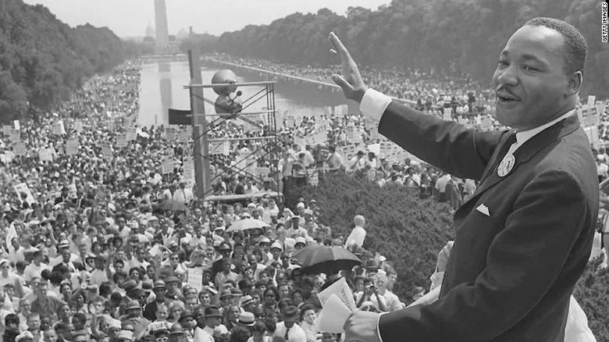

Write a two to three sentence interpretation of this historical picture

Quote of the Week:
“In face of adversity, it is the will and desire to overcome obstacles which determines the outcome.”
Mr. Kay

