Big 3 Warm Up 01/11

Word of the Day:
Deprecate \verb

Definition(s):
1. To disapprove of strongly.
2. To belittle; to depreciate

Example:
To bespeak the importance of small parks is not to deprecate the importance of big ones.

Use the word of the day in a sentence and underline the word.

8th Grade Social Studies Trivia:

What are the six flags that have flown over Texas?

Picture Response:

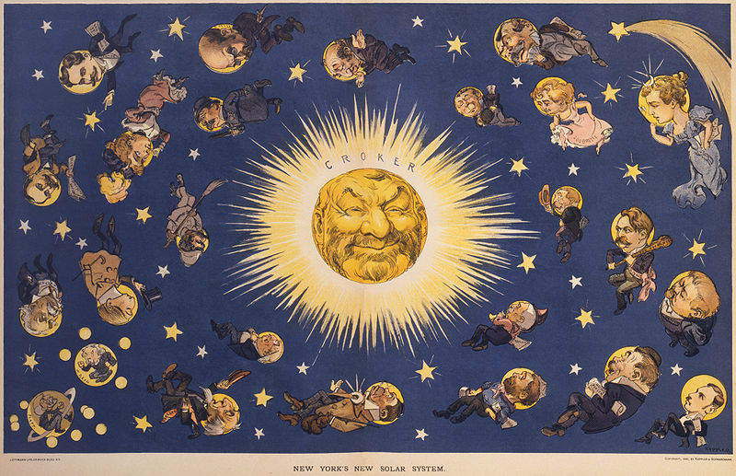

Write a two to three sentence interpretation of this historic painting

The flags of Spain, France, Mexico, the Republic of Texas, the Confederacy, and the U.S..

Quote of the Day:
“Actions speak louder than words.”

