**Big 3 Warm Up 01/10**

**Word of the Day: Artifice**

Definition:

**1.** Cleverness or skill; ingenuity; inventiveness.  
**2.** An ingenious or artful device or expedient.  
**3.** An artful trick or stratagem.  
**4.** Trickery; craftiness; insincere or deceptive behavior.

Example Sentence:

Built by design and **artifice**, it fell apart in confusion and chaos.

Use the word of the day in a sentence and underline the word.

**8th Grade Social Studies Trivia:**

1. Which US politician said, "Always forgive your enemies, but never forget their names?"

2. What was the first U.S. Navy ship named in honor of an African American?

**Picture Response:**

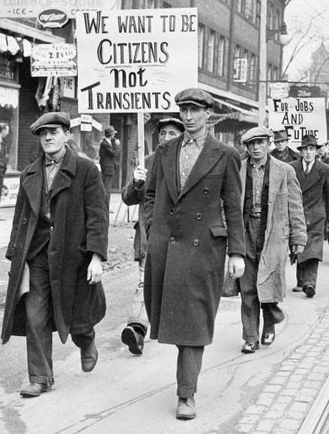

**Write a two to three sentence interpretation of this historic painting**

**Quote of the Day:** “Actions speak louder than words”

**Answer Trivia:**

A: Bobby Kennedy.

A: The U.S.S. Harmon, named after Leonard Roy Harmon, a mess attendant who was killed at

Guadalcanal on July 25, 1943