Big 3 Warm Up September 28th

Word of the Day:

Burden (noun)
Definition: A load; something which is borne or carried with difficulty.

Example Sentence: After staying with her friend for three weeks, Sarah began to feel she was becoming a burden and so decided to find a place of her own.

In order to receive full credit, you must create your own sentence using the word of the day. You must underline the word of the day in your sentence.

8th Grade Social Studies:

After the Civil War the U.S. sued which country for damages that were caused by them building ships for the Confederacy? We originally asked for $1 billion but settled on $25 Million.

Picture Response:

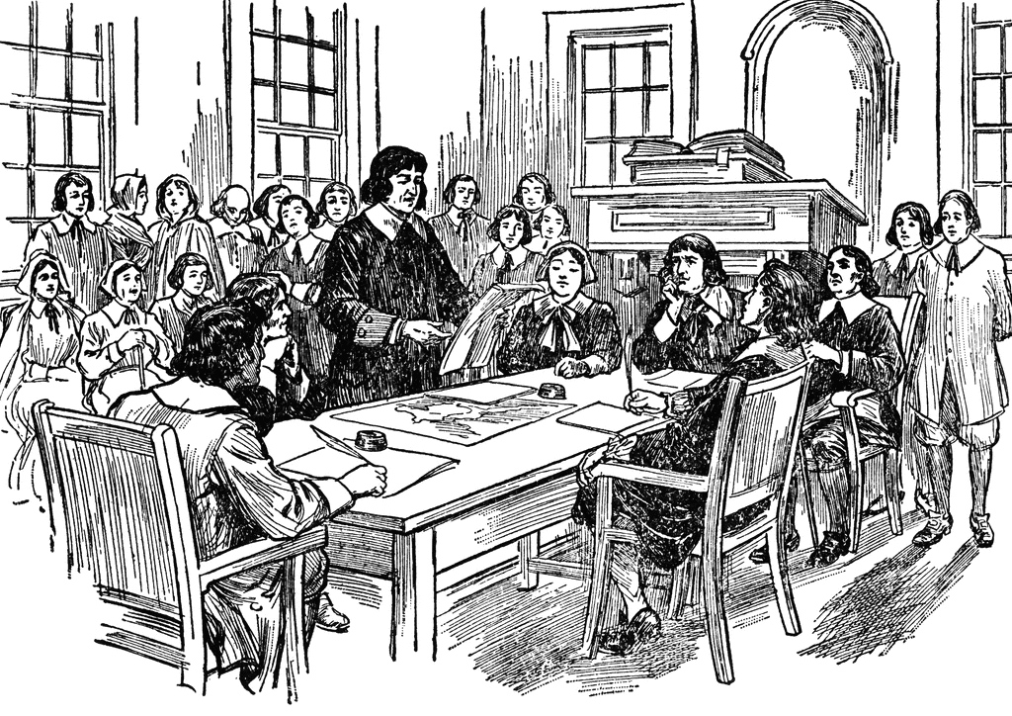

Write a two to three sentence interpretation of this historic painting

Great Britain
Quote of the Day:
“Actions speak louder than words.”

