Big 3 Warm Up September 25th

Word of the Day:

Permanent

Definition: continuing or enduring without marked change in status or condition or place

Example Sentence: Think twice about writing in permanent marker or getting a tattoo because both are just about impossible to erase.

In order to receive full credit, you must create your own sentence using the word of the day. You must underline the word of the day in your sentence.

8th Grade Social Studies Trivia:

What is the most common first name for a president or some variation of it?

Picture Response:
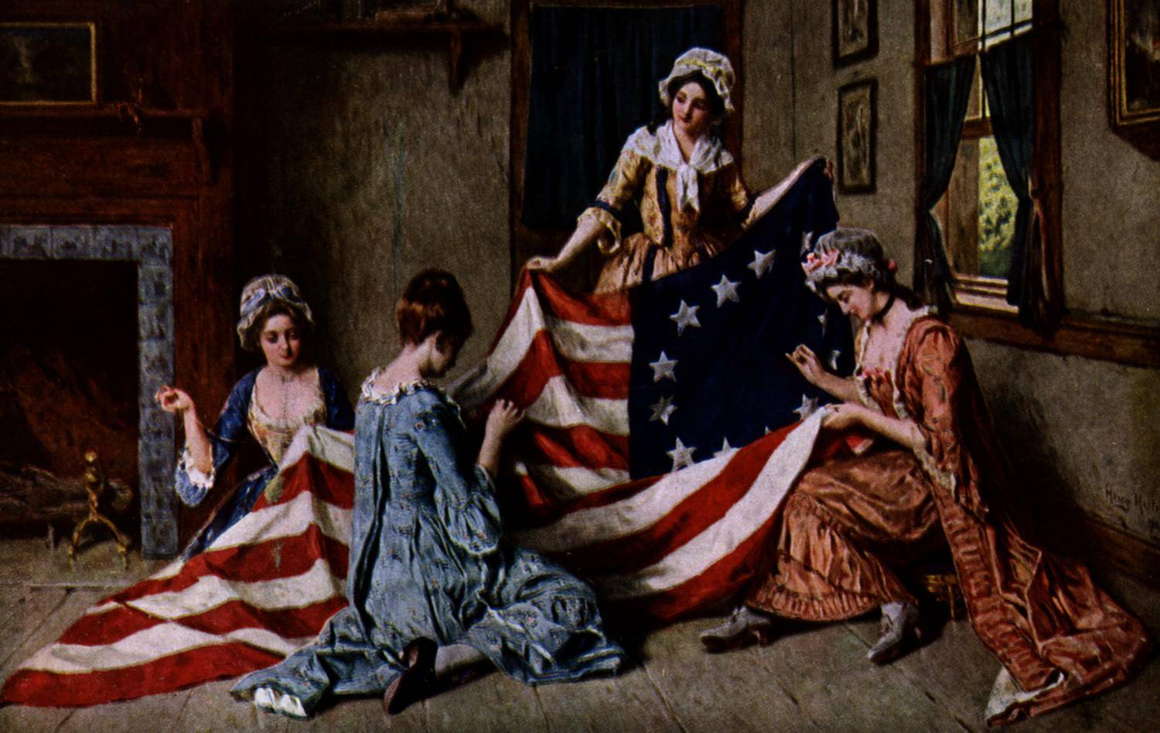

(In order: James Madison, James Monroe, James Polk, James Buchanan, James Garfield, Jimmy Carter)

James

