Big 3 Warm Up September 12th

Word of the Day:

Plagiarize • verb
Definition: Take without referencing from someone else’s writing or speech; of intellectual property

In order to receive full credit, you must create your own sentence using the word of the day. You must underline the word of the day in your sentence.

8th Grade Social Studies Trivia:

Take the case of (blank), a U.S. congressman in the nineteenth century. This person wanted more than anything else to be President of the United States. He was offered the vice-presidency by William Henry Harrison, but turned it down. Then Harrison died in office. Again this person was offered the vice-presidency, by Zachary Taylor, but declined. Taylor died in office. This person never did become President, who is he?

Picture Response:

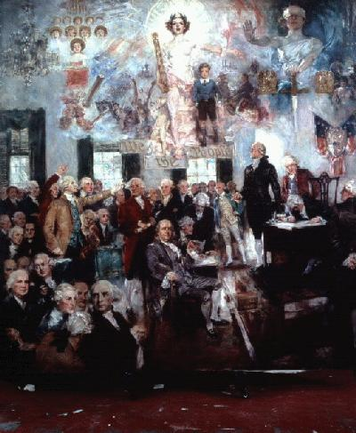

Write a minimum of two to three sentences explaining and or detailing what you see in the above painting

Quote of the Day:
“Actions speak louder than words.”

Daniel Webster

