Big 3 Warm Up 10/05

Word of the Day:

Immigrant

Definition: A person who leaves one country to settle permanently in another.

EXAMPLE SENTENCE:
After a journey that could range from a week to several months, the immigrants would arrive in New York City, Boston, Philadelphia, Galveston, or another American port.

Please write a sentence using the word of the day. Underline the word of the day in your sentence.

8th Grade Social Studies Trivia:
What is the name of the author who wrote, Give me your tired, your poor, your huddled masses yearning to breathe free." in the Poem The New Colossus in 1883?

Picture Response:
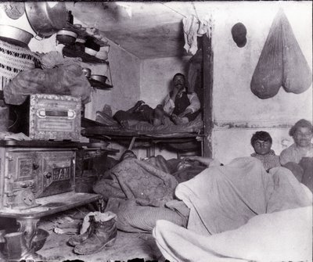

Write and two to three sentence response

Emma Lazarus

