Big 3 Warm Up 11/08

Word of the Day: Filibuster

Definition:
1. An attempt by a Senator or group of Senators to obstruct the passage of a bill, favored by the majority, by talking continuously.
2. Because there is no rule in the Senate over how long a member can speak, a Senator can prevent a bill from coming up for a vote by talking endlessly. Senator Strom Thurmond of South Carolina set the record in 1957 by speaking for more than 24 hours without stopping.

Example Sentence: A group of senators plans to filibuster a measure that would permit drilling in Alaska.

Use the word of the day in a sentence in which you created and underline the word of the day.

8th Grade Social Studies Trivia:

When do the *Electoral College* voters elect the President?

Picture Response:
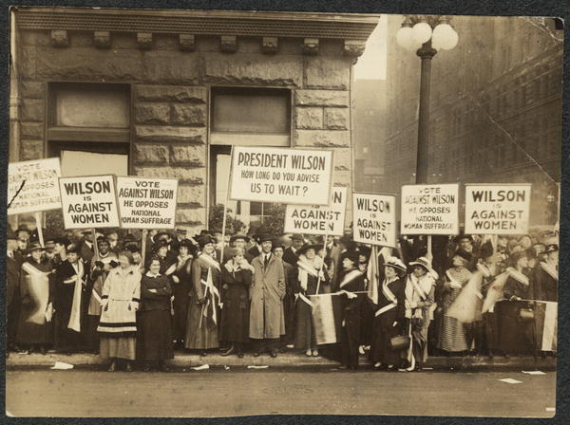

Write two to three sentences response based on your interpretation of this historic photograph

Quote of the Day: “One must always maintain one's connection to the past and yet ceaselessly pull away from it.” -Gaston Bachelard

Answer Trivia : First Monday following the second Wednesday in December. So the electors cast their ballots more than a month after the general population votes.

