**Big 3 Warm Up for 11/29**

## Word of the Day:

**Continual (adj)**

Definition(s):

Without pause or break.

Example Sentence:

The continual noise from the construction site so infuriated the neighbors that some threatened to sue the developer.

Use the word of the day in a sentence that you have created and underline the word.

**8th Grade Social Studies Trivia:**

### What First Lady became the first wife of a sitting president to appear under subpoena before a grand jury?

### Whose assassination resulted in the Lorraine Motel being named the National Civil Rights Museum?

**Picture Response:**

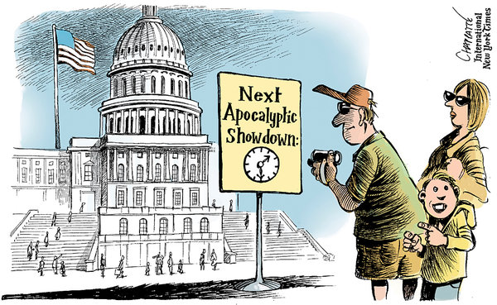

**Write a two to three sentence interpretation of this painting**

**Quote of the Day:**

[“I am a success today because I had a friend who believed in me and I didn't have the heart to let him down...”](http://www.quotesdaddy.com/quote/288/abraham-lincoln/i-am-a-success-today-because-i-had-a-friend-who-believed)

- Abraham Lincoln

**A:** Hillary Rodham Clinton.

**A:** Martin Luther King Jr's.