**Big 3 Warm Up 11/27**

**Word of the Day: Doughty**\DOW-tee\, *adjective*:

Definition:

**1.**  Marked by fearless resolution  
**2.**  Valiant  
**3.**  Brave

Example Sentence:

He was obsessed with the Arctic, his imagination stoked by epic accounts of the **doughty** pioneers who had led wooden ships into uncharted waters and northern mists.

Use the word of the day in a sentence that you have created and underline the word.

**8th Grade Social Studies Trivia:**

1. Who did James Earl Ray shoot in Memphis in April 1968?

2. Who was the first president of the first university for African Americans in the United States of America?

**Picture Response:**

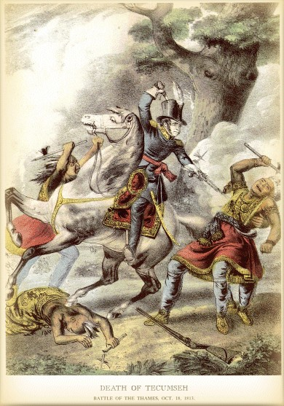

**Write a two to three sentence interpretation of this historic painting**

**Quote of the Day:** “Actions speak louder than words”

**Answer Trivia:**

A: Dr. Martin Luther King Jr.

A: Booker T Washington