Big 3 Warm Up 11/12

Word of the Day: barrage

noun
- Military. a heavy barrier of artillery fire to protect one's own advancing or retreating troops or to stop the advance of enemy troops.
- an overwhelming quantity or explosion, as of words, blows, or criticisms: a barrage of questions.

Example Sentence: I became numb to the barrage of smells: citrus disinfectants, burning trash, sewage, sweat, and diesel.

8th Grade Social Studies Trivia
What was Veteran’s Day known as in the past? Why?

Picture Response
Write two to three sentences based off the picture
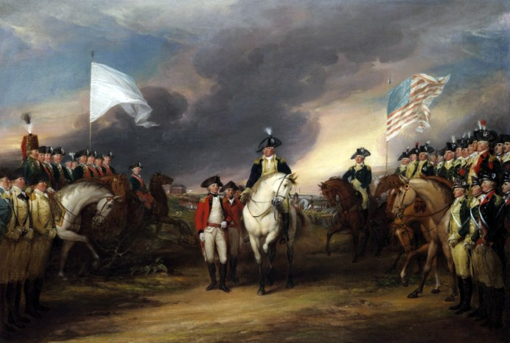

Quote of the Day
“The American Revolution was a beginning, not a consummation.”
- Woodrow Wilson

Armistice Day

