Big 3 Warm Up 5/4

Word of the Day:

Incriminate • verb
1. suggest that someone is guilty
2. bring an accusation against; level a charge against

Example Sentence:
A student in 6th hour incriminated himself of cheating of his test
World History/Government Trivia:

Question 1: Who was the only US president who later swore-in another US President?
Question: 2: In 1838, the US government forcibly moved 15,000 members of this Indian tribe from their peaceful homes in Georgia to the Oklahoma territory. Four thousand of them died along this "Trail of Tears." Which Indian tribe was displaced in this manner?

Picture Response:

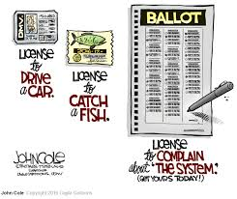

William Howard Taft
CHEROKEE

