Big 3 Warm Up 5/16

Word of the Day:

Iridescent • adjective
Definitions:
1. Varying in color when seen in different lights or from different angles
2. Having a play of lustrous rainbow colors

Example Sentence and Video:
Dr. Dakin, a biologist and other researchers had found that the most successful male peacocks had the most iridescent blue-green color in the tail eye-spots.

https://www.youtube.com/watch?v=LzCYuRjX3FI

World History/Government Trivia:

Question 1: Can you name the last four sitting Presidents who lost bids for re-election for a second term?
Question: 2: Three of the first five U.S. presidents died on July 4th, who were they?

Picture Response:

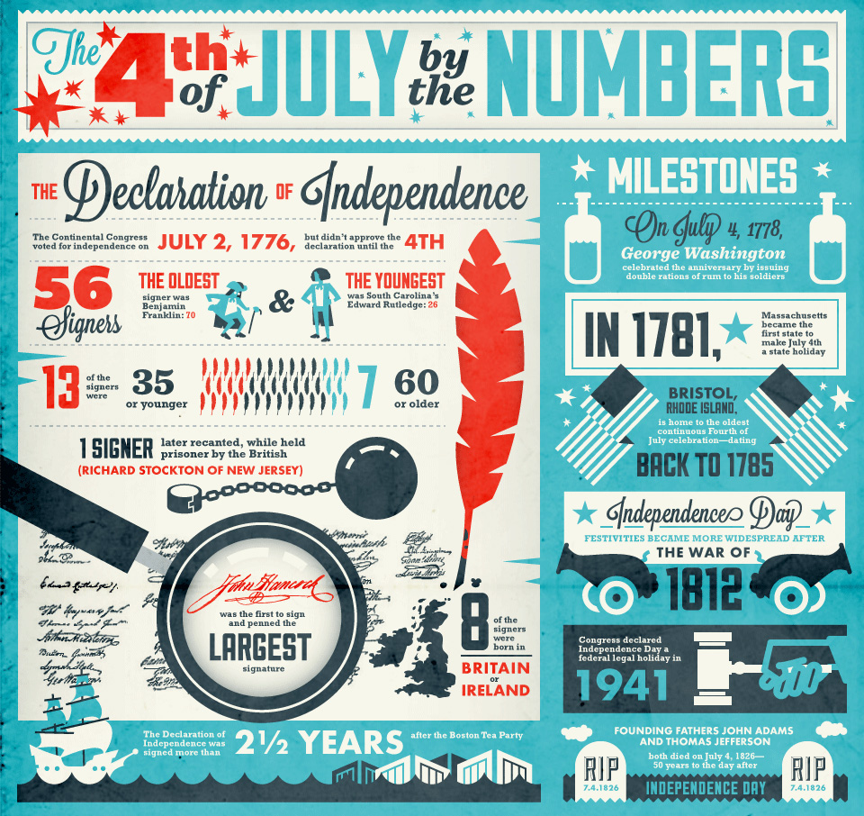

Question 1:
GEORGE BUSH - lost to Clinton in 1992
JIMMY CARTER - lost in 1980 to Reagan
GERALD FORD - lost in 1976 to Carter
HERBERT HOOVER - lost in 1932 to FDR

Question 2:
Three of the first five U.S. presidents died on July 4. John Adamsand Thomas Jefferson died in 1826, the 50th anniversary of the country's birth. Adams' last words were “Thomas Jefferson still survives.” James Monroe, the fifth president, died five years later in 1831.

