**Big 3 Warm Up 03/08**

**Word of the Day:** Diplomat

Definitions:

A person who helps people who have differing points of view find common ground.

In government, a diplomat is an official who represents his or her country in other nations.

Example Sentence:

The diplomat spoke on condition of anonymity ahead of an expected announcement.

Use the word of the day in a sentence and underline the word.

**8th Grade Social Studies Trivia:**

Mary Kies was the first woman to be granted a US Patent. What did she invent?

**Picture Response:**

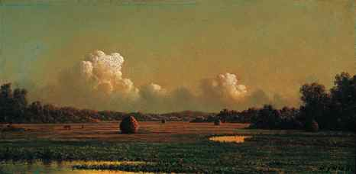

**Write a two to three sentence interpretation of this historic painting**

**Quote of the Day:** “Actions speak louder than words”

First recipient of a patent granted to a woman by the United States Patent and Trademark Office, on May 5, 1809, which was for a technique of weaving straw with silk and thread.

Straw weaving was an economically vital industry in America during the 1800s. Women wore straw hats for working in the field. The Patent Act of 1790 opened the door for anyone, male or female, to protect his or her invention with a patent. However, because in many states women could not legally own property independent of their husbands, many women inventors didn't bother to patent their new inventions. Mary Kies broke that pattern on May 5, 1809.

**Answer Trivia:**

A: Thomas R Marshall.

A: $40 million.